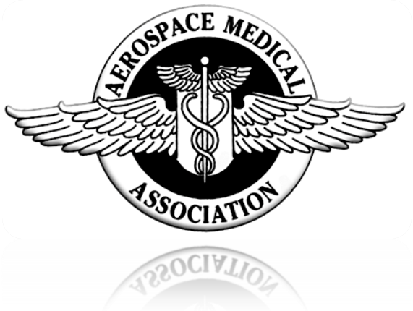

Minutes of the
Aerospace Medical Association
Council Meeting

May 9, 2010

Sheraton Phoenix Downtown Hotel
Phoenix, Arizona
COUNCIL MEETING
AEROSPACE MEDICAL ASSOCIATION
MAY 9, 2010
SHERATON PHOENIX DOWNTOWN HOTEL
PHOENIX, AZ

Call to order (Weien)
  - Dr. Weien welcomed everyone to Phoenix, AZ and called the meeting to order at 9:00 AM.
2. Approval of Council meeting of November 18, 2009 (Weien)

  - The Council meeting minutes of November 18, 2009 were reviewed and one change was recommended. It was recommended that the word “dollars” be removed from the second sentence of paragraph 5.b. The recommended change was approved and with that change the Council meeting minutes of November 18, 2009 were approved.
- Report of Executive Committee (Weien)
  - Executive Committee met March 5-6, 2010 in Colorado Springs, CO. All of the issues discussed will be briefed later during the Council meeting.
  - An AsMA Past President requested time to address the Council on an important matter and the President offered him time.
    - Workshop #2 – Aviation Health Issues from the Pilot Perspective was presenting topics as fact but science does not support. Workshops did not follow the peer-review process for approval yet were offering CME credits.
    - The Past President was concerned that attendees might interpret the information presented during this workshop as AsMA policy even though it is not AsMA policy and not peer-reviewed.
    - The President decided to insert a slide at the end of the workshop proceedings that stated the information presented during the workshop were the views of the presenters and did not represent AsMA policy.
    - Council motion was made, seconded and approved to refer the issues of (1) whether to require peer-review of workshops and (2) can said workshops offer CME to the Education and Training Committee. (OPEN - ER201005-1 Workshop Approval Process - Webb)

- GOVERNANCE (SIDES)
  - Home Office (Sventek)
    - The ED reviewed Home Office Staff benefits and reported to Council
      - Salaries – Low for area non-profit organizations
      - Work Hours – EXCOM approved 7.5 hrs/day
      - Paid Time Off – EXCOM approved a PTO accrual program based on longevity with AsMA:

Longevity (Years) | Annual (Days/yr) | Sick (days/yr)
0 – 3 | 16 (10 hrs/mo) | 12 (7.5 hrs/mo)
3 – 5 | 19 (11.875 hrs/mo) | 12 (7.5 hrs/mo)
5 – 10 | 21 (13.125 hrs/mo) | 12 (7.5 hrs/mo)
Over 10 | 24 (15 hrs/mo) | 12 (7.5 hrs/mo)

        - EXCOM approved a reduction in the maximum number of days staff can carry over from one year to the next from 60 days to 30 days
        - EXCOM approved ten paid Federal Holidays plus two paid floating holidays each year:
          - New Years Day (January)
          - Martin Luther King, Jr. Birthday (January)
          - President’s Day (February)
          - Memorial Day (May)
          - Independence Day (July)
          - Labor Day (September)
          - Columbus Day (October)
          - Veterans Day (November)
          - Thanksgiving Day (November)
          - Christmas Day (December)

          - Two floating paid holidays - employees would be able to use these floating paid holidays any time during the year.
          - Bereavement Leave of three days.
          - Flexible Leave plan to be developed by ED and presented to EXCOM (OPEN – GOV201003-1 Flexible Leave Program – Sventek).
      - Disability Insurance – EXCOM approved short-term and long-term disability insurance for staff
      - Health Insurance – EXCOM approved recommendation to remain with current HMO plan.
      - 401k Plan – EXCOM approved recommendation to maintain current Safe Harbor plan and investment program
      - Group Life & Accidental Death and Dismemberment Insurance – EXCOM approved recommendation to not purchase for staff due to high cost and little staff interest
      - Group Dental Insurance – EXCOM approved recommendation to not purchase at this time due to high cost and limited staff interest.
      - A lengthy discussion related to Voluntary Leave Transfer Programs or Leave Donation Programs ended with a recommendation for the ED to collect more information on this issue and report back to the Executive Committee at the next meeting. (OPEN – GOV201003-2 Leave Donation Program - Sventek)

    - IMPak (ISSI) Update (Sventek)

      - ED reported significant progress in modifying the IMPak database to meet the needs of the Association. Progress had been made in:
        - Meeting Registration Module
        - Membership Management Module
        - Subscriptions Module
      - ED reported those modules that still required modification:
        - Accounting Module
        - Fellows’ Data Integration
        - Committees Integration
        - Surveys Integration
      - ED reported the IMPak database is a robust software package offering AsMA capabilities in a consolidated database. Plans to maximize these capabilities include consolidating data from the Fellows and Associate Fellows databases, offering server space for Fellows, Associate Fellows and Constituent Organizations websites to be hosted, integrating all websites on the AsMA hosting server with the IMPak database to facilitate membership management, and working to allow members to pay their all appropriate membership dues at one time on-line.

      - The ED announced the Home Office transitioned from the Lan2Wan DSL service (3 mbps/768 kbps) to Comcast Business cable (22 mbps/5 mbps) in mid-March 2010 in an effort to increase the data transfer rates between the users in the AsMA Home Office and the IMPak database located on the HostMySite.com server. Transition provides greater capability at less cost and saves AsMA over $550.00 per year.

  - Finances (Merchant)

    - 501(c)(3) IRS Status – (Sventek)
      - Articles of Incorporation were published in October ASEM journal
      - Vote to occur during Annual Business Meeting on May 10, 2010
      - Once updated Articles of Incorporation approved by membership, ED will meet with attorney to complete 501(c)(3) application paperwork with the District of Washington – could take six months for approval after application is submitted. (OPEN – GOV201003-4 Apply for 501(c)(3) IRS Status – Sventek)

    - Arrange Audit – (Merchant)
      - Audit was purposely delayed to allow new ED to get established. Audit will be discussed during next EXCOM. (OPEN – GOV201003-5 Arrange Audit – Merchant)

    - Prepare Ethics Statement – (Merchant)
      - Little progress made. The perceived value of this statement is still questioned. Recent workshop issues combined with ACCME focus on conflicts of interest make this initiative important. (OPEN – GOV201003-6 Prepare Ethics Statement – Merchant)

    - Finance Report (See attached slide presentation)
      - AsMA experienced at $341,568 loss in 2009 as a result of multiple factors:
        - Increased expenses in the form of depreciation, maintenance, credit card fees, insurance, website, mailings, education/training, pensions, bonuses, journal and travel.
        - Decreased revenues in the form of decreased membership, reduced meeting revenue, and reduced journal revenue
        - Accounting adjustments in the form of accrued leave liability and several one-time accounting adjustments. (OPEN – GOV201003-3 Ideas for Improving Financials – Sventek/Merchant)

  - Committees

    - Bylaws Committee (Lischak)
      - Update Policy and Procedures Manual
        - President-Elect identified this as her #1 initiative for the coming year.
        - Bylaws Committee Chair established an ad hoc working group with representation requested from each Constituent Organization, Standing Committee, and AMSRO. EXCOM members are invited to provide their inputs for improving the manual. Council members were asked to please ensure their organizations identify their point of contact for this effort.
        - The Policy and Procedures Manual Working Group will meet to discuss the way ahead (OPEN – GOV201003-7 Update Policy and Procedures Manual – Lischak/DeJohn)
      - Bylaws Changes (Lischak)
        - Proposed changes to the AsMA Bylaws were published in the February 2010 ASEM and will be voted on during May 10, 2010 Business Meeting in Phoenix, AZ.
        - Policy and Procedures working group will continue work through calendar year 2010 with plans to publish an updated manual. Marian Sides and Chuck DeJohn will ensure proper integration of the manual changes with the AsMA Bylaws (changes will need Council vote for approval). (OPEN – GOV201003-8 Bylaws Changes – Lischak)

    - Nominating (Jennings for Hastings)
        - 2010 Slate of Nominees
          - President-Elect: Fanancy Anzalone, MD
          - Vice President: Susan Northrup, MD
          - Vice President: Philip Scarpa, MD
          - Member-at-Large: Richard Bachmann, MD
          - Member-at-Large: Charles Fisher, MD
          - Member-at-Large: Robert Johnson, MD
          - Member-at-Large: David Rhodes, MD
          - Member-at-Large: Gabor Hardicsay, MD (2 yr term)

- EDUCATION AND RESEARCH (WEBB)

  - Editor’s Report (Bonato) – See attached report

  - Managing Editor’s Report (Day) – See attached report

  - Annual Meeting (Sventek)

    - Percentage of room block sold – 97% of room block

    - Number of registrations – 1008 Advance registrants

    - Number of exhibitors – 35 exhibitors/46 exhibit spaces
      - ER-1 AMDA Exhibits (Weien/Sventek) – ED and President-Elect discussed issue with AMDA and determined the small number of exhibitors does not pose a problem for the Association. Efforts to encourage the AMDA exhibitors to join the AsMA exhibits will continue. (CLOSED – ER201003-1 AMDA Exhibits – Sides/Merchant/Sventek)
      - NB-1 Organize Airline Medical Department Workshop (DeBois) – A seminar on this subject will be convened at the meeting in Phoenix. (OPEN – ER201003-2 Organize Airline Medical Department Workshop – DeBois)
      - ER-2 Survey Exhibitors (Sventek)
        - Work with Herlitz to organize survey of exhibitors
        - EXCOM members make 100% contact with exhibitors and discuss:
          - Wireless connectivity
          - Coffee location and availability for attendees
          - Satisfaction with their assigned location
          - Lunch in exhibit hall on Tuesdays during the meeting
          - Which countries they are focused on for their products/services (OPEN – ER201003-3 Survey Exhibitors – Sventek)

    - Scientific Program (Crowley) – See attached presentation
      - ER-3 Explore Feasibility of PowerPoint/Podcast (Crowley/Shender)
        - AsMA purchased a 1TB external hard drive and has it available to collect all presentations from meeting. AV Tech contractor will work with the Scientific Program Committee to ensure presentations are downloaded from the meeting room laptop computers to the external hard drive each evening. Collected presentations will be transported back to the AsMA Home Office, converted to PDF format and made available on the AsMA website.
        - Questions were raised about charging a nominal fee for accessing the presentations on-line. A suggestion was made that registered meeting attendees could access for free, AsMA members that did not attend the meeting would pay a small fee and non-members that did not attend the meeting would pay a higher fee to access the presentations.
        - A motion was made to allow ExComm, in concert with S&T Committee, to decide on the proposal’s organization and financing, and execute (by Home Office). The motion carried unanimously. The President requested the ED to check with other non-profit organizations to determine their processes for collecting, organizing meeting presentations on their websites. ED will also collect information on pricing schemes used and explore the feasibility of producing a meeting DVD for sale.. (OPEN – ER201005-2 Meeting Presentations On-Line – Sventek)

    - General
      - ER-4 Apply for Cephalon Grant for Historical Supplement (Russo/Sventek) – COL Russo requested grant for this purpose but Cephalon was not supportive. (CLOSED)

    - Committees
      - Aerospace Human Factors – See attached report
      - Aviation Safety – See attached report
      - Education & Training – See attached report
        - ER-5 Slideshows (Boudreau) – Both slideshows are available for Council members to review and provide comment during Wednesday, May 12 Joint Council Meeting. (OPEN – ER201003-4 Slideshows – Boudreau)
        - ER-6 ASM Compendium (Boudreau) – Compendium is nearly complete. Dr. Jarnail Singh will work with Dr. Webb to provide additional information on international programs/research. Dr. Webb is also working with CDR Park, President of the IAMFSP about help from them on the international data. (OPEN – ER201003-5 ASM Compendium – Boudreau)
        - ER-7 Journal MOC/CME Feature (Boudreau/ASAMS)
          - MOC/CME journal feature suspended in 2008 due to suboptimal utilization.
          - Continuing concerns about cost-effectiveness of journal CME/MOC
          - Need approved process for handling MOC/CME. Most physicians requiring MOC/CME have clear parameters set by their respective certifying boards for MOC/CME content. Some physicians cannot use AsMA MOC/CME to meet those requirements.
          - There is a lot of free CME available for those that don’t require or cannot use AsMA MOC/CME.
          - ASAMS physicians are those that require the Aerospace Medicine MOC/CME. (OPEN – ER201003-6 Journal MOC/CME Feature – Boudreau/ASAMS)
      - History & Archives – See attached report
        - ER-8 Reinhartz Historical Lecture Series (Mohler) – See attached report. AMSRO members are involved with recording interviews. (OPEN – ER201003-7 Reinhartz Historical Lecture Series – Mohler)
      - Science & Technology (Shender) – See attached report
        - Chair announced anyone can submit topics for the S&T Watch columns
          - 1,500 words with 1 high resolution graphic maximum
        - AsPS and the Aerospace Human Factors Association will co-host a function on Wednesday evening in Phoenix. It is open to the public and will be advertised at the meeting itself.

- MEMBER SERVICES (SILBERMAN) Jeff Myers presented the report

  - Membership Status/Dues (Carter) – See attached report

  - General

    - MS-1 Membership Ad Hoc Initiative (Sides) – Ad hoc committee has completed its work and will execute the survey they designed
      - Survey will be used to evaluate how AsMA can improve perceived value of membership to our members
      - Once survey is complete, the ad hoc committee dissolves and the Membership Committee will run the analysis and implement initiatives to improved perceived value. (CLOSED – MS201003-1 Membership Ad Hoc Initiative – Sides)
  - Committees

    - Awards (Holland) – See attached report. An additional issue was raised for thought and further discussion in the future: consider announcing the award nominees and recipients ahead of the Awards Banquet to allow affected individuals to make appropriate plans.

    - Membership (Ortega) – See attached report

    - Corporate & Sustaining (DeBois) – See attached report

- REPRESENTATION AND ADVOCACY (MANNING)

  - Outreach (Sventek)

    - ED is working with the American Meteorological Society, the NASA Applied Sciences Program and the CDC National Center for Environmental Health/Agency for Toxic Substances and Disease Registry (NCEH/ATSDR) to determine if improved communication and collaboration with these agencies would enhance the environmental medicine components of our Association focus. These agencies have been completing research that shows health effects associated with changes in the atmosphere. They are looking for an appropriate venue to present their information. The AsMA annual scientific meeting and our journal may provide those venues. (OPEN – RA201003-1 Environmental Medicine Advocacy – Sventek)

    - ED, with inputs from AsMA physician members, responded to an ACGME proposal to eliminate the Masters in Public Health requirement for the Residency in Aerospace Medicine.

  - AMA Activities (Ortega)

    - Dr. Berry and Dr. Ortega will participate in the AMA Medical Student Section Showcase at the AMA HOD Annual Meeting in June. Showcase offers AsMA the opportunity to introduce the Aerospace Medicine specialty to medical students to assist them in their career decisions.

    - AsMA ordered a table drape in blue with a white AsMA logo for this and other promotional events to help attract students to the AsMA table.

  - Committees

    - Air Transport Medicine Committee (Dowdall) – See attached report

    - Communications (Dervay) – See attached report

    - Resolutions (Gillis) – See attached report
      - RA-1 Resolutions/Letters on Aircrew Fatigue (Caldwell)
        - Two fatigue resolutions will be presented at the AsMA Business Meeting on May 11, 2010.
          - Resolution 2009-01-Rev 5 (in-flight napping)
          - Resolution 2009-02-Rev 5 (sleep-enhancing agent use off-duty and layovers)
        - The two fatigue resolutions were presented to ICAO during a recent meeting of the ICAO Fatigue Management Task Force. The international community will not add the resolutions in the ICAO Fatigue Risk Management Manual. (OPEN – RA201003-2 Resolutions/Letters on Aircrew Fatigue – Caldwell)
- INTERNATIONAL SERVICES (SINGH)

  - General – Dr. Singh would like to use the International Reception during the annual scientific meetings to expand membership. He would like to expand the reception to a theme-based, formal session. (OPEN – IS201003-1 Theme-Based International Reception – Singh)

  - Committees

    - International Activities (Hardicsay)
      - There is a trend in Europe of decreasing aeromedical requirements

- CONSTITUENT REPORTS
  - Aerospace Human Factors Association(King) – See attached report
  - Aerospace Nursing Society (Taylor) – See attached report
  - Aerospace Physiology Society (Musashe) – See attached report
  - Airline Medical Directors Association (Landsman) – See attached report
  - American Society of Aerospace Medicine Specialists (Johnson) – See attached report
  - International Association of Military Flight Surgeon Pilots (Park)
  - Life Sciences and Biomedical Engineering Branch (Tripp) – See attached report
  - Society of U.S. Air Force Flight Surgeons (Matarese) – See attached report
  - Society of U.S. Naval Flight Surgeons (Heil)
  - Space Medicine Association (McGinnis) – See attached report
  - U.S. Army Aviation Medicine Association (Woodson)

- OTHER REPORTS
  - Aerospace Medicine Regent Report (Armstrong) – See attached report
  - Affiliates
    - Aerospace Medical Association of Korea
    - Aerospace Medical Association of Taiwan
    - Aerospace Medical Association of the Philippines
    - Aerospace Medical Student & Resident Organization – Report Attached
    - Alliance of Air National Guard Flight Surgeons
    - Association of Aviation Medical Examiners, United Kingdom
    - Association of Aviation, Space, Naval, Extreme & Environmental Medicine of Russia
    - Association of USAF Reserve Flight Surgeons
    - Australasian Society of Aerospace Medicine
    - Aviation Medical Society – New Zealand
    - Brazilian Aerospace Medical Society
    - Canadian Aerospace Medicine & Aeromedical Transport Association
    - Civil Aviation Medical Association
    - Corporate & Sustaining Membership Affiliate – Report Attached
    - Danish Aviation & Naval Medical Association
    - European Society of Aerospace Medicine – Report Attached
    - French Aerospace Medical Association
    - German Society of Aviation & Space Medicine – Report Attached
    - Greek Aerospace Medical Association
    - Hellenic Aerospace Medical Society
    - Ibero-American Society of Aerospace Medicine – Report Attached
    - International Association of Aerospace Dentistry – Report Attached
    - International Committee of Medicine and Physiology
    - Israeli Society of Aerospace Medicine
    - Italian Aviation & Space Medicine Association
    - Japan Society of Aerospace & Environmental Medicine
    - Middle Eastern Society of Aerospace Medicine
    - Norwegian Association of Aviation Medicine
    - SAFE Association
    - Slovenian Aerospace Medical Association
    - Society of NASA Flight Surgeons
    - South African Aerospace Medical Society
    - Spanish Society of Aviation & Space Medicine
    - Swedish Aviation & Naval Medicine Association
    - The Romanian Society of Aerospace Medicine
  - Associate Fellows Group (White)
  - Fellows Group (Mapes)
  - Aerospace Medical Association Foundation (Jennings) – Report Attached

- NEW BUSINESS

  - Recommendation of the Undersea and Hyperbaric Medicine Society for Affiliate status
    - Council approved Undersea and Hyperbaric Medicine Society for Affiliate status. (CLOSED)
  - Proposed changes to the AsMA Bylaws, Article VIII, Section 3, paragraph B. requirement for “up-to-date list or roster of its members in good standing, giving name, residence, and connection with aerospace medicine or its allied sciences. (Sventek)
    - ED recommended this requirement be removed from Bylaws to protect the privacy of members.
    - ED will draft recommended change to Bylaws and submit to Bylaws Committee for action. (OPEN – RA201005-1 Sensitive Information – Sventek)
  - Process for approving Corporate & Sustaining Membership application process. (Sides/Sventek)
    - AsMA Bylaws requires all Corporate & Sustaining applicants to be approved by the Executive Committee.
    - No process in place to accomplish this approval.
    - ED established process of accepting application and payment, granting applicant provisional Corporate & Sustaining membership.
    - ED sends application documents and other information on the applicant to the Executive Committee via e-mail and collects approval/disapproval votes.
    - If Executive Committee approves the application, ED signs Corporate & Sustaining membership letter and certificate. Letter and certificate are included in a welcome package that is sent to the new Corporate & Sustaining member.
    - Council approved this process (CLOSED)
  - Restrictions for winning/applying for scholarships (Sventek)
    - One individual applied for all available scholarships and had won a scholarship the previous year.
    - ED recommended a time restriction between winning a scholarship and applying for another scholarship.
    - Council disagreed with the ED and recommended no restrictions be placed on the application process. Council trusts the Executive Committee to make appropriate decisions on the scholarships. There was a suggestion to make one common form to use for all the scholarships (CLOSED)

- A motion to adjourn was made and seconded. The AsMA Council was adjourned at 3:30 PM on May 9, 2010.

Jeffrey C. Sventek, MS, CAsP
Executive Director
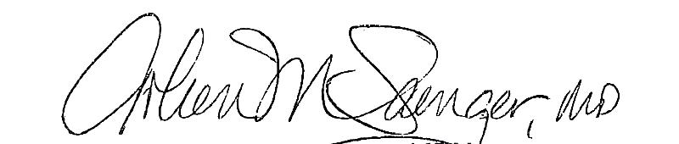
Arleen M. Saenger, MD, MPH
Secretary
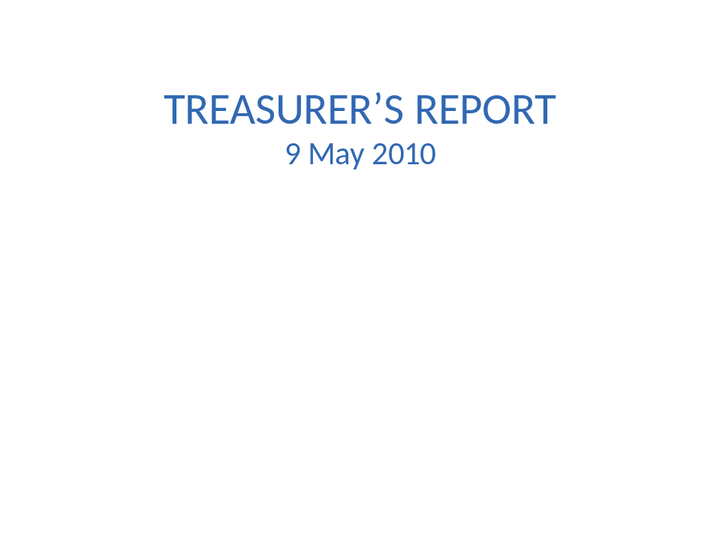

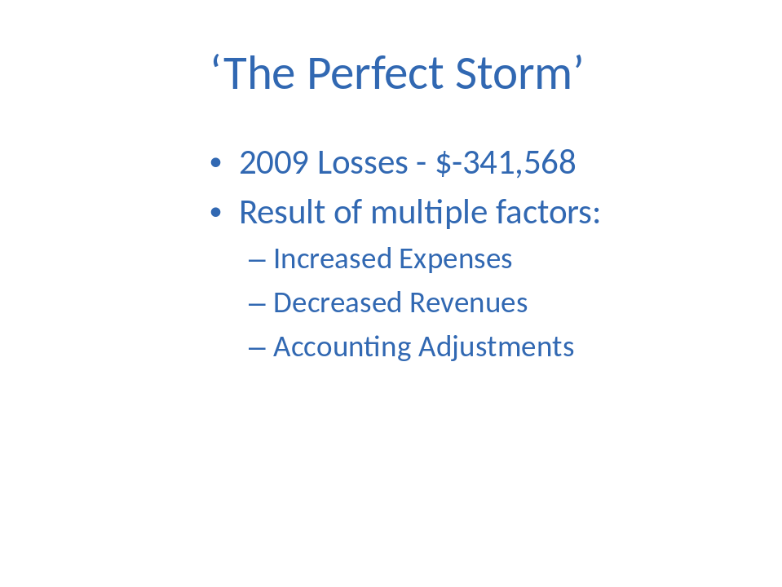

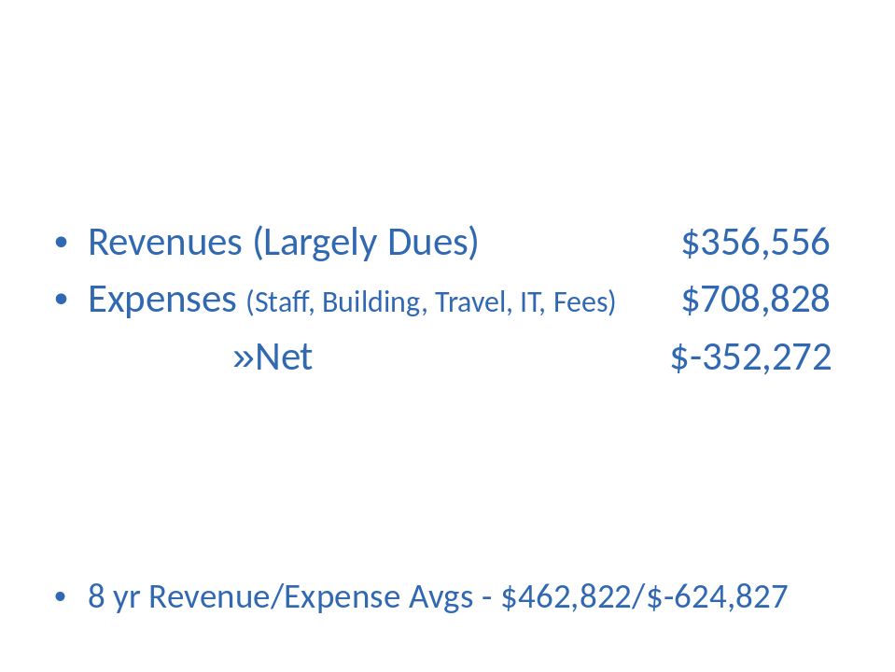

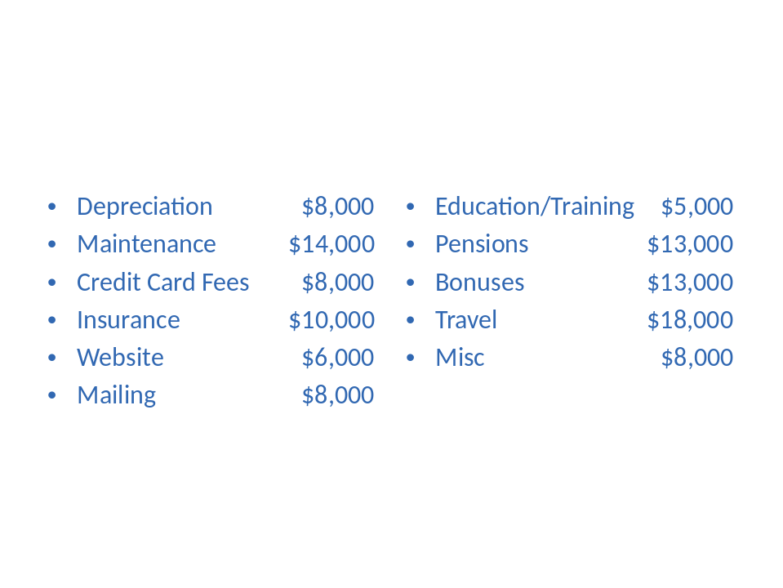

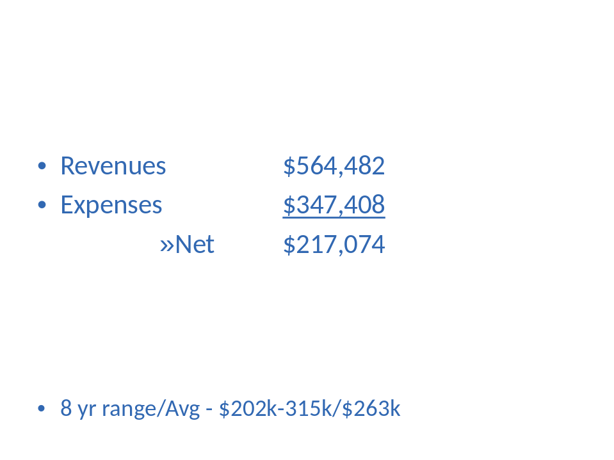

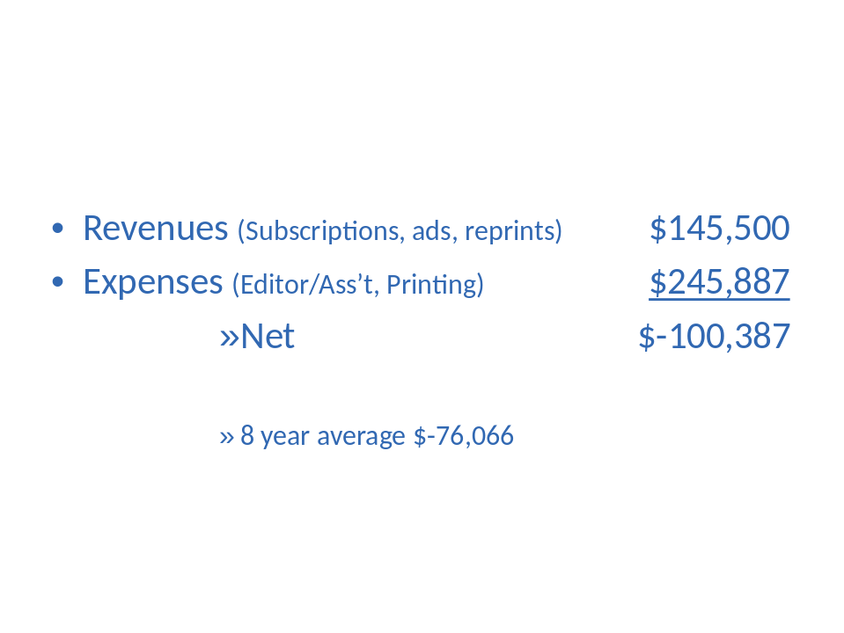

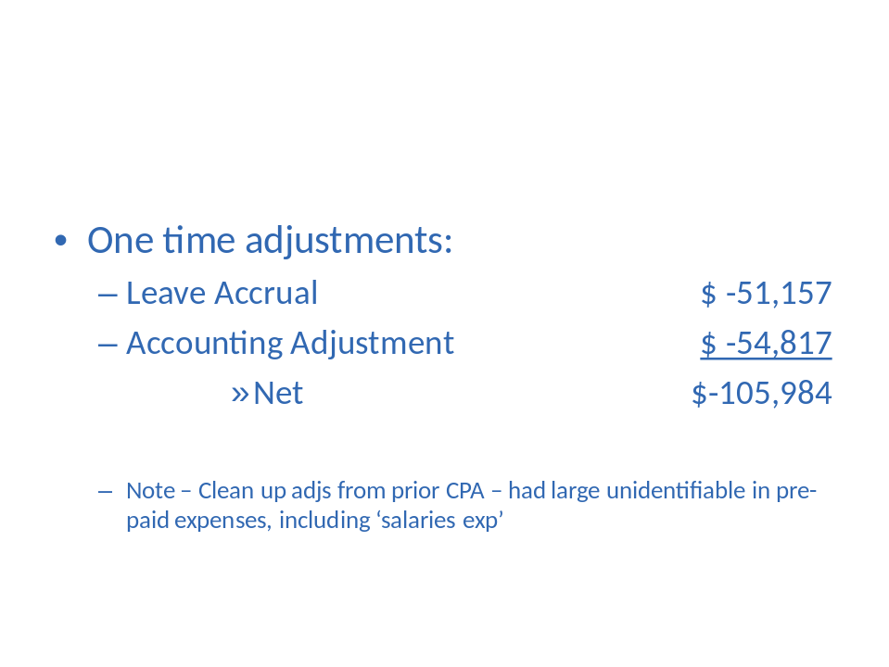

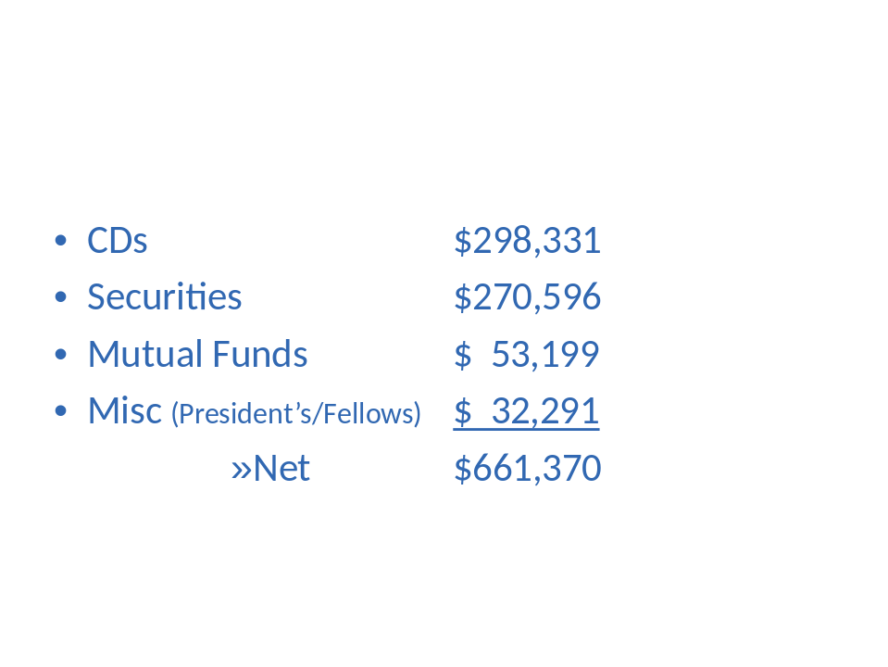

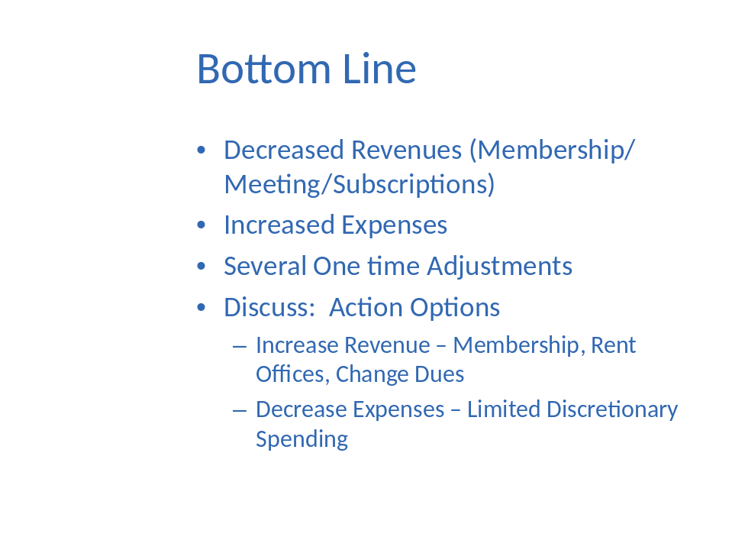

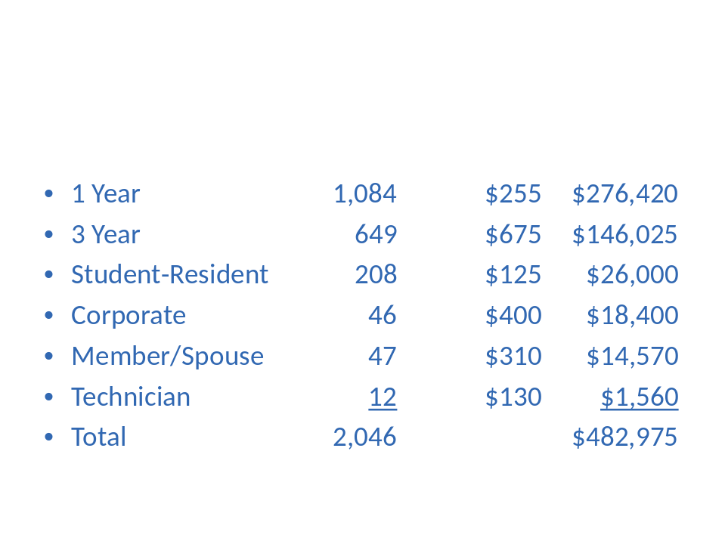

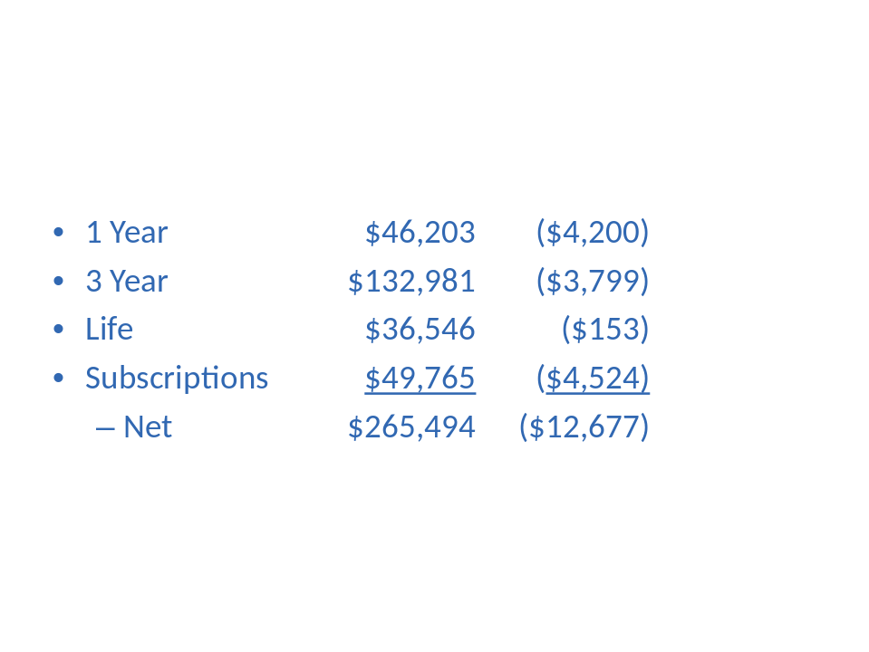

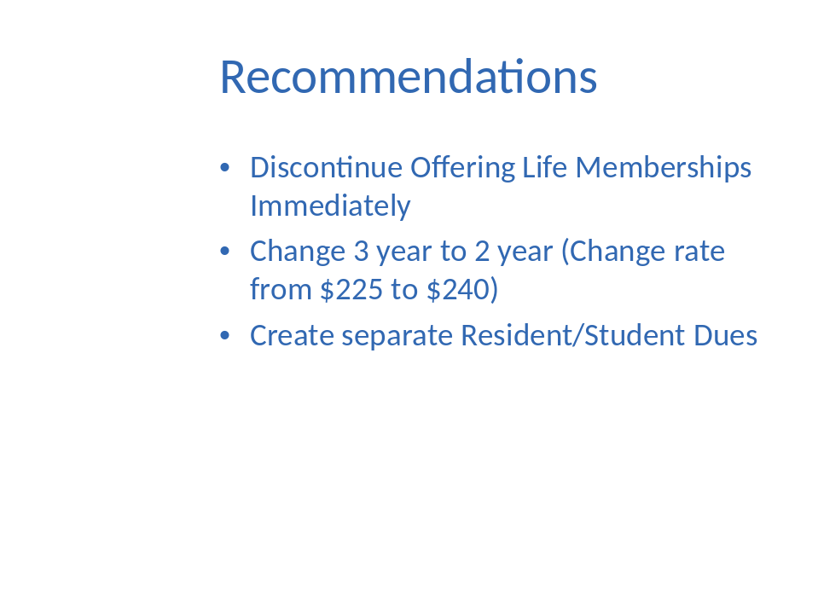

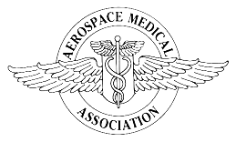
Aviation, Space and Environmental Medicine
To: AsMA Council
From: Frederick Bonato, Ph.D.
Subject: ASEM Editor-in-Chief’s semi-annual report
1. Editor-in-Chief Transition- It’s been almost five months since I officially took on the role of the journal’s editor-in-chief (EIC). The transition was well thought out and effective—by October 2009 I was handling all new submissions so by January 2010 I was fully immersed in my new role. I am grateful for Dr. Sally Nunneley’s guidance during the transition and her continued willingness to provide advice on all things related to the journal. In fairness to our authors, Sally followed through on manuscripts that she started work on. Sally is now listed in the journal’s masthead as Editor Emerita and she continues to edit the journal’s features on a voluntary basis. She has been, and continues to be, a tremendous asset to both the journal and me.
2. Assistant to the EIC- When I was first hired I was informed that the Assistant to the EIC, Sarah Pierce-Rubio, would be stepping down. Sarah subsequently agreed to stay on until the AsMA meeting in May 2010 (this meeting). I am happy to report that Sarah has agreed to stay on at least until the end of the year. I have a full appreciation for all that Sarah does to keep things running smoothly. I rely on her experience often and her attention to detail and tactful way of dealing with people is exceptional. I am thankful that she has agreed to stay on at least for a while longer.
3. Journal Staff- I am very pleased with the way the entire journal staff interacts with each other. Communication is excellent and the team works well together. There are checks and balances that work well. Pam Day and Rachel Trigg do a great job at their end and I am grateful for what they do. Although he is not “journal staff,” I am also grateful for Jeff Sventek in his new role. He has been most supportive of the journal and responds quickly and thoughtfully to all issues that arise.
4. Associate Editors- Currently, the Associate Editors for ASEM are:
Jan Stepanek, M.D., M.P.H.- Clinical Aerospace Medicine
Michael Barratt, M.D.- Space Medicine
David Rhodes, M.D., M.P.H.- Resident Case Reports
Geoffrey McCarthy, M.D.- Book Reviews

I am grateful for their support and advice, especially when thorny issues arise. Their expertise in their respective areas and has benefited our journal immensely. It is good to know there are people such as them that the journal can rely on. Thanks to them for their dedication and service.
I should note here that earlier this year, Dwight Holland decided to step down as an associate editor of book reviews. We thank Dwight for his valuable service to the journal and wish him well. Geoff McCarthy will serve as the journal’s sole book review editor and he has been enthusiastic in pursuing new review opportunities.
Also, David Ludwig had served in an associate editor’s position as a statistical consultant. David is no longer serving in that capacity but we should all thank him for his past service to ASEM. I have decided to not seek a replacement for David. My own background in statistics has been sufficient to handle most issues. When I feel I need some advice I have numerous colleagues with statistical expertise to rely on even within my own academic department.
5. Editorial Board- It seems appropriate that we should all thank those serving on the ASEM Editorial Board. Their names are listed below. Having such a diverse, qualified and distinguished group of individuals to rely on for advice has been valuable. Many thanks to them all for their service and dedication.
Mike Bagshaw, M.B., Ch.B.
Eilis Boudreau, M.D., Ph.D.
Jay Buckey, M.D.
Malcolm Cohen, Ph.D.
Victor Convertino, Ph.D.
Mary Anne Frey, Ph.D.
Mitchell A. Garber, M.D., M.S.M.E.
David Gradwell, Ph.D., M.B., B.S.
Richard Jennings, M.D., M.S.
Raymond E. King, M.A., Psy.D.
Matt Lewis, M.D.
Terrence Lyons, M.D., M.P.H.
David Newman, M.B., B.S., Ph.D.
Scott A. Shappel, Ph.D.
Dougal Watson, M.B., B.S.

6. Current Journal Status
The following statistics describe activity over the past six months (since November 1, 2009):
New manuscripts received = 137 (including features)
New manuscripts received for peer-review = 108
(Research Articles- 74, Short Communications- 18, Review Articles- 3, Case Reports- 9, and Commentaries- 4)
Number of peer-reviewed manuscripts removed/declined/rejected (of the 108) = 33 (approximately 31%). Note: this percentage will rise as manuscripts under review are rejected.
Number (of the 108) still under review = 49 (approximately 45%)
On April 25, 2009 we had 119 manuscripts in the pipeline, meaning manuscripts either assigned or under review. As of April 29, 2010 we had 108 in the pipeline. These numbers represent a snapshot comparison of the two dates. The mean number of manuscripts in the pipeline this year was 117 (based on weekly sampling). For the previous year the mean number of manuscripts was 99. Overall, these numbers can be interpreted as indicating a somewhat stable level of submissions.
We do have a backlog of accepted peer-reviewed manuscripts, but not a very large one. I currently aim for selecting 68-70 pages of peer-reviewed material for each issue of ASEM. Our backlog of accepted material has been around 30-45 pages since January. Although it would be beneficial in some ways to have a larger backlog of manuscripts, it is most important to preserve the quality of ASEM. A small backlog does put more pressure on the journal’s staff, but I feel confident that we are only accepting the material that meets our high standards.

REPORT OF THE MANAGING EDITOR
TO: Council of AsMA
FROM: Pamela Day, Managing Editor
SUBJECT: Journal Operations
DATE: May 2010
Journal Operations: Transitioning to the new Editor as well Executive Director is going very smoothly. We have a good backlog of manuscripts at the moment.
According to Ingenta our journal ranks in the top 100 out of more than 13,530 titles for number of full-text downloads. For the period March 1, 2010 to March 31, 2010: Aviation, Space, and Environmental Medicine ranks 9th with 5592 downloads. I believe this is because we offer all of our features, including the “You’re the Flight Surgeon” articles, for free.
We have changed paper in an effort to save a bit of money. The new paper is actually a bit higher grade—heavier, whiter, and more opaque—but the cost is so much less than our previous stock that even with slightly higher associated postage costs, we will still save a few hundred each month. We are also trying a new international mailing company in another cost-saving measure.
I attended a seminar in publishing trends as well as a webinar on using Facebook. We will be looking into new platforms and formats and digital content in the near future.
I took a photography course to learn more about the digital camera as and I will again be the AsMA photographer for Phoenix.
Rachel has created a Corporate and Sustaining membership page for the web. She has also created a list of scholarships in Aerospace Medicine. She will soon be working with our new web hosting company to design and maintain a new website.
We are exploring our options regarding multi-site licensing and creating consortia for large groups of subscribers. We are working with Ingenta and have asked other associations to weigh in on how they handle tiered and large group subscriptions.
E-mail News: Dr. Manning suggested that we send out an e-mail announcement of the news online and perhaps send occasional news announcements via blast e-mail. Rachel has set up a template to send these news announcements. Gisselle found an inexpensive (free) way to send blast e-mails, so we are now doing this on a regular basis.
Supplements: I have had a couple of inquiries into publishing supplements, but nothing concrete.
Abstract Submission: All in all the ScholarOne system performed well for us. We will be using this system for at least 2 more years.
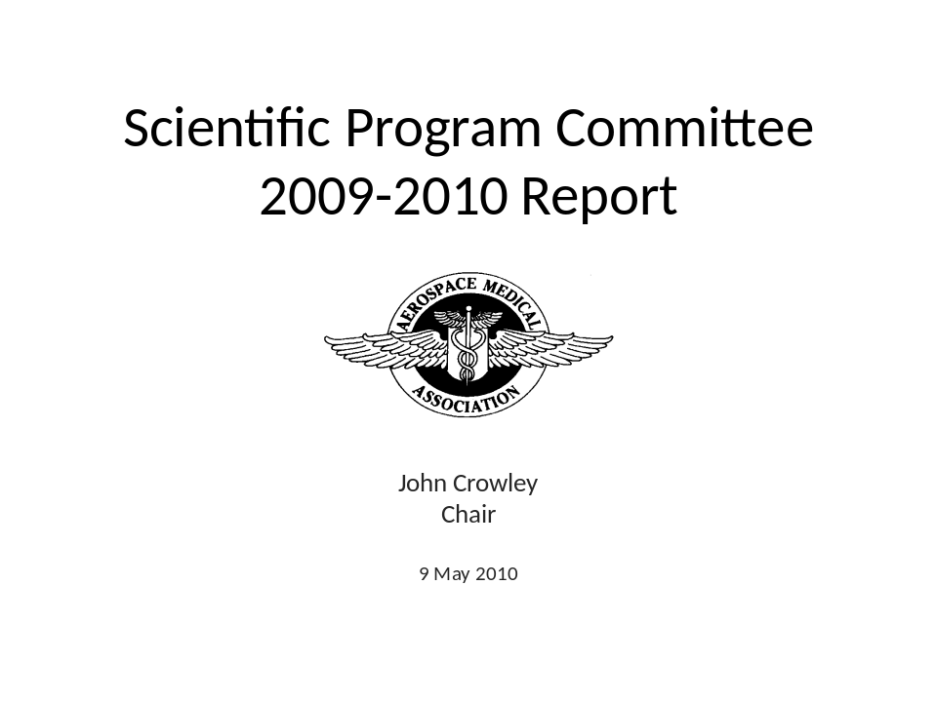

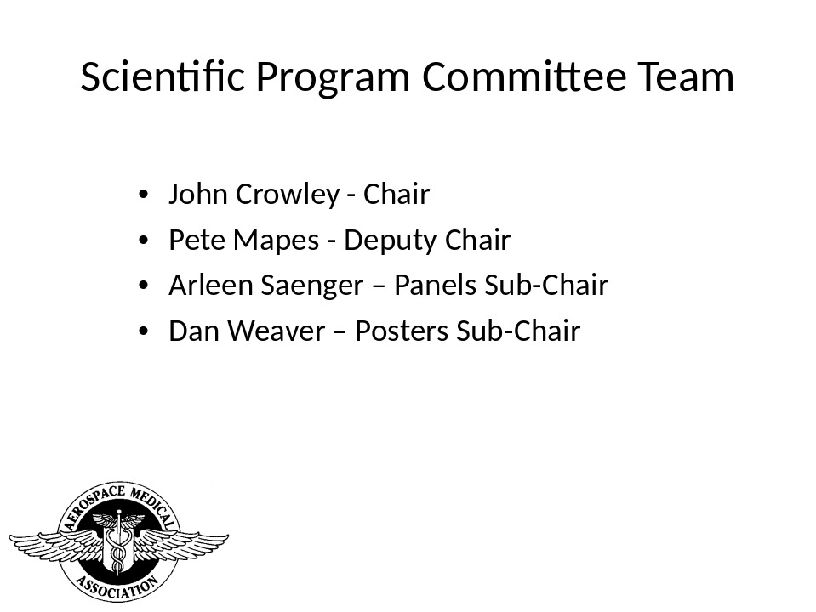

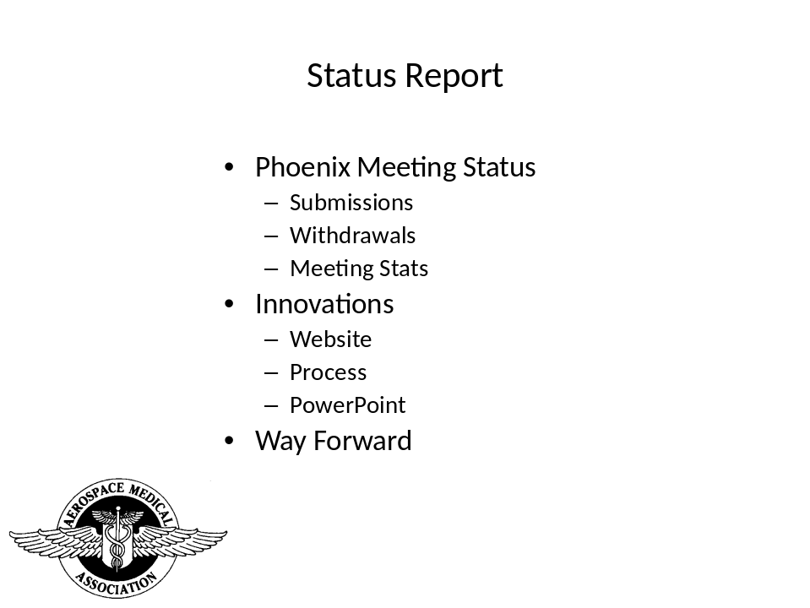

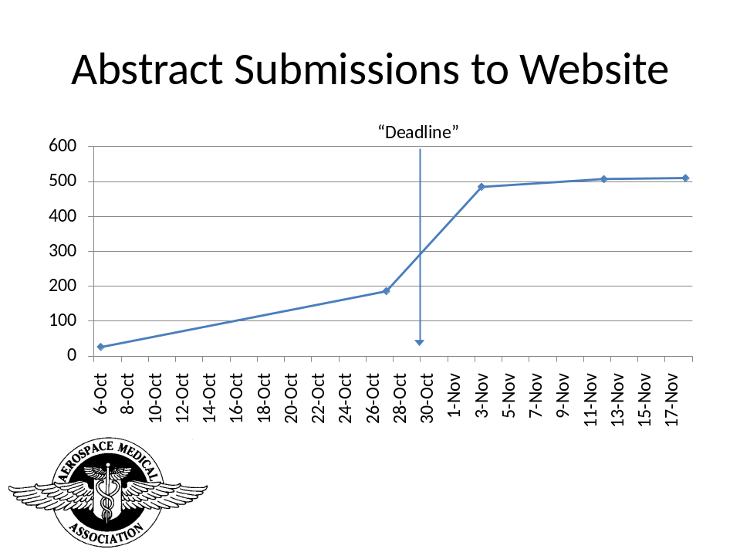

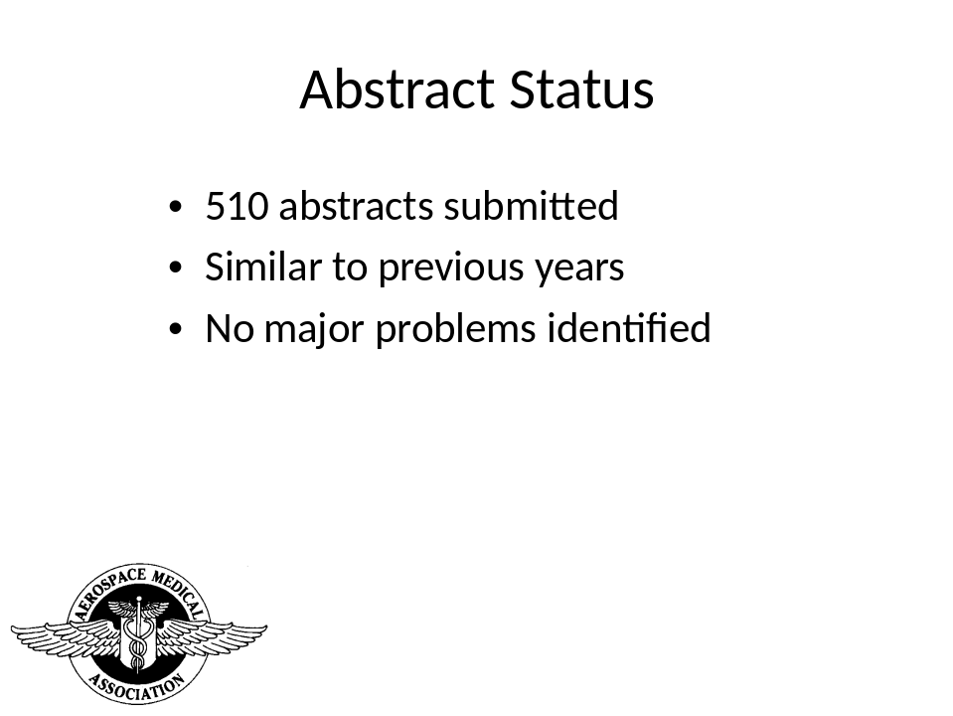

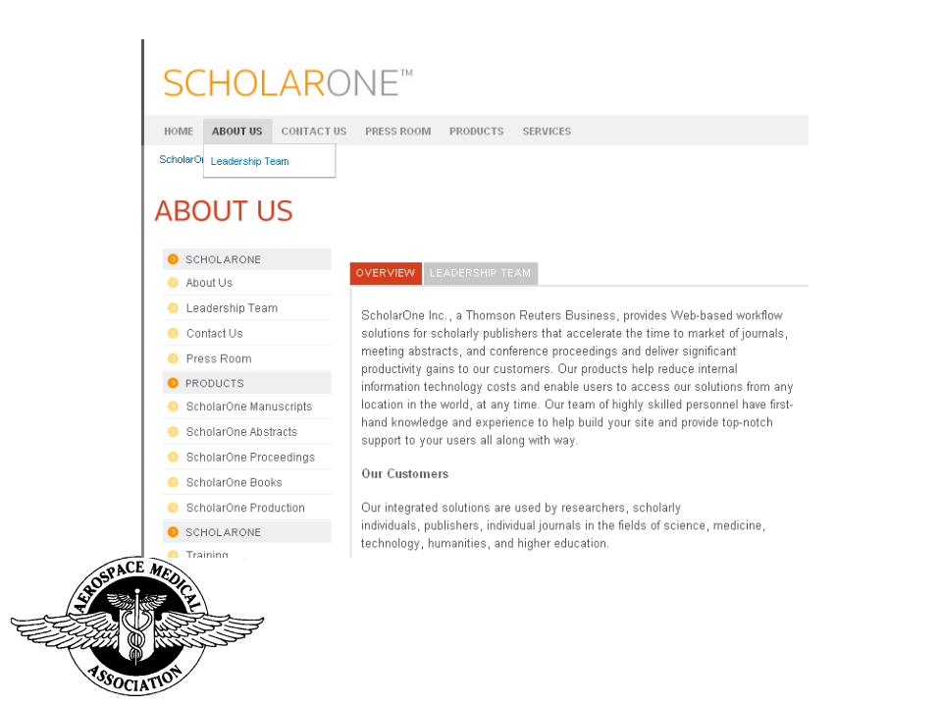

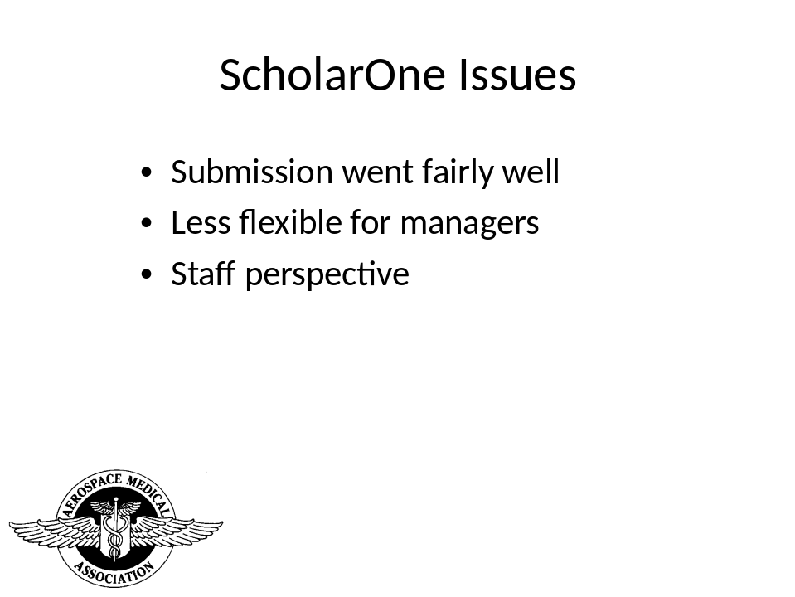

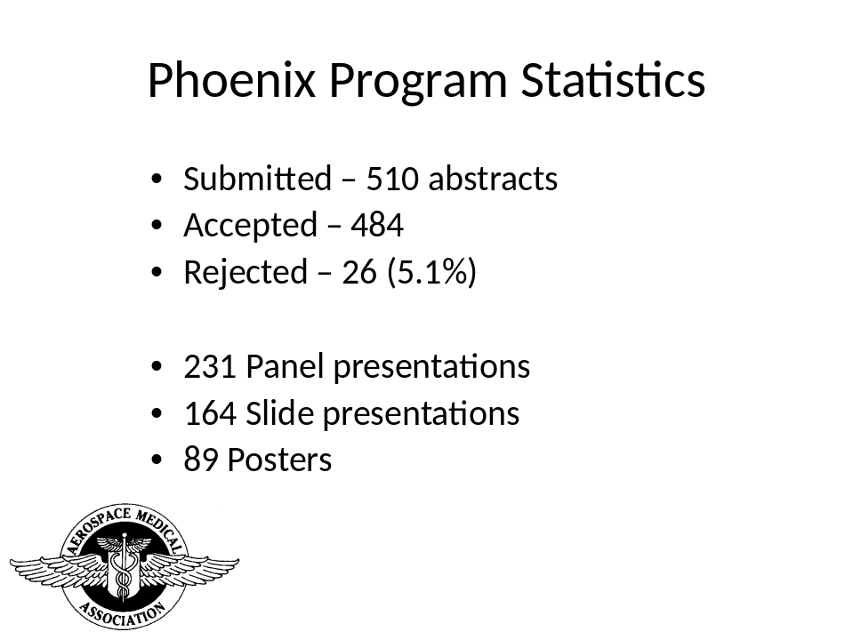

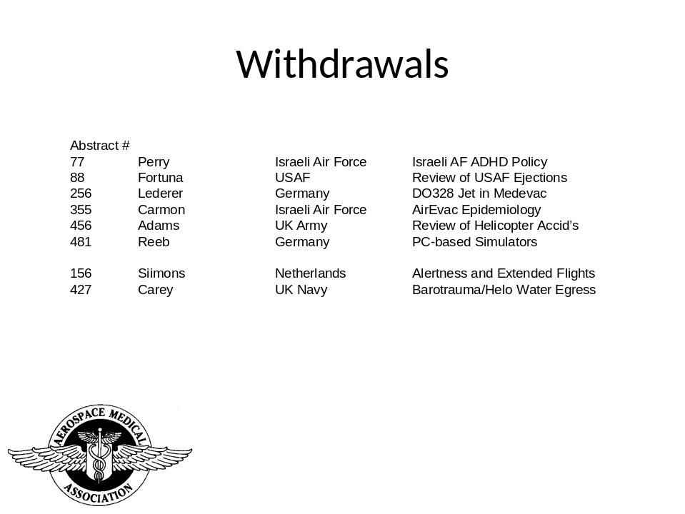

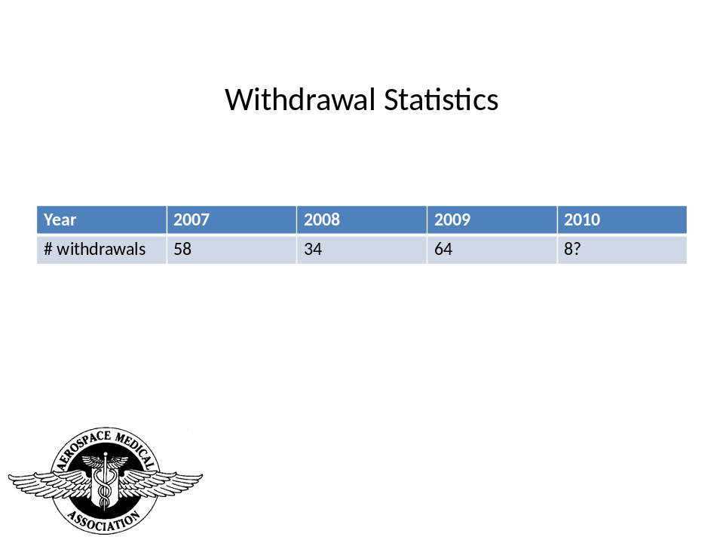

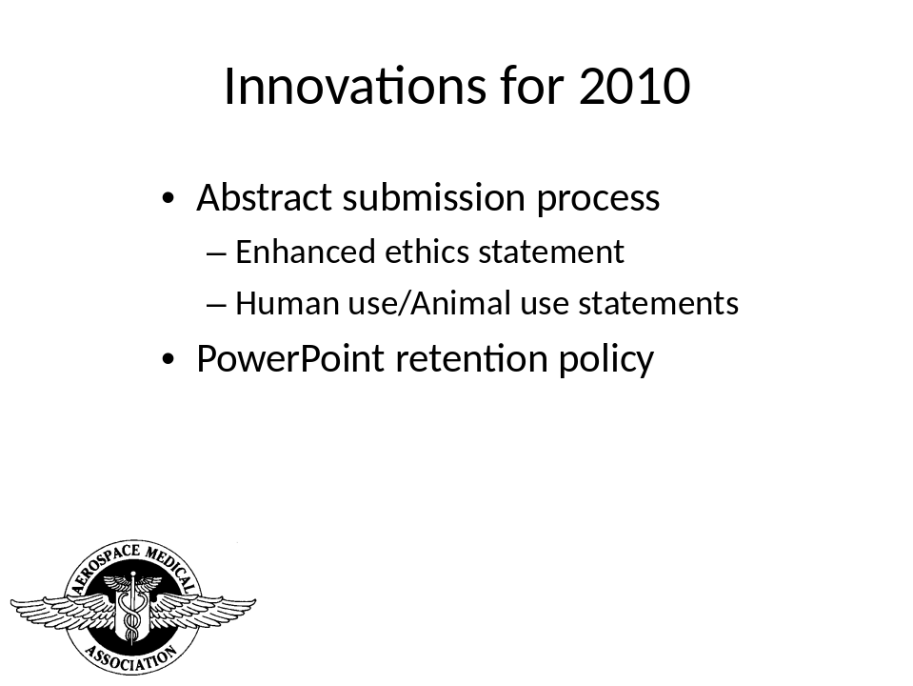

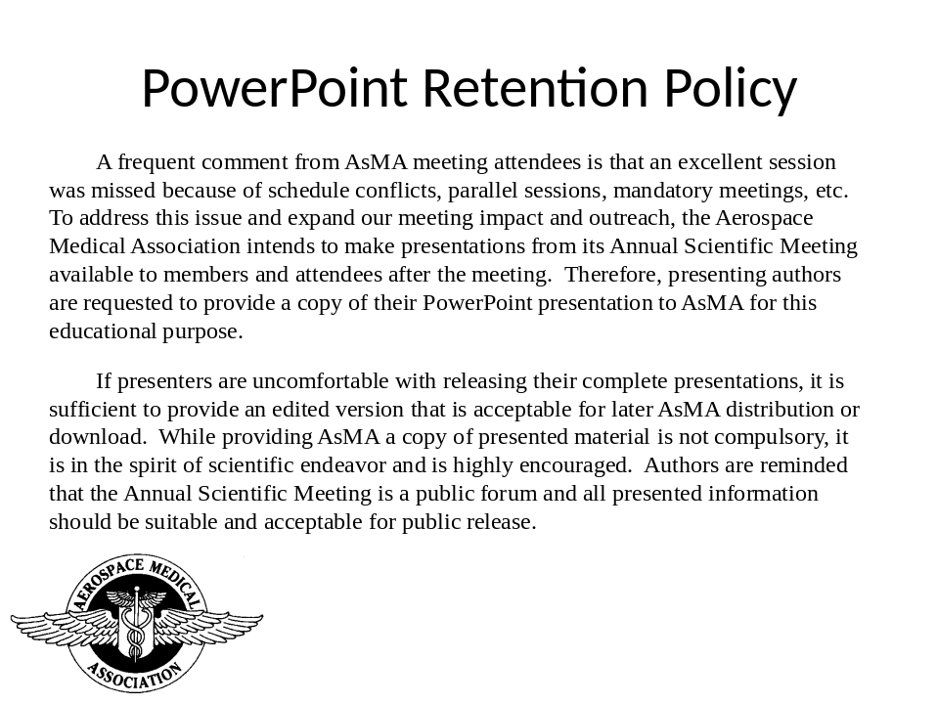

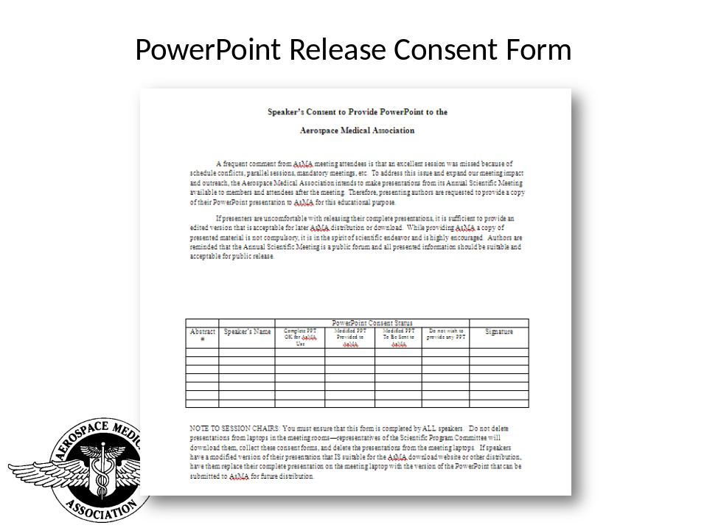

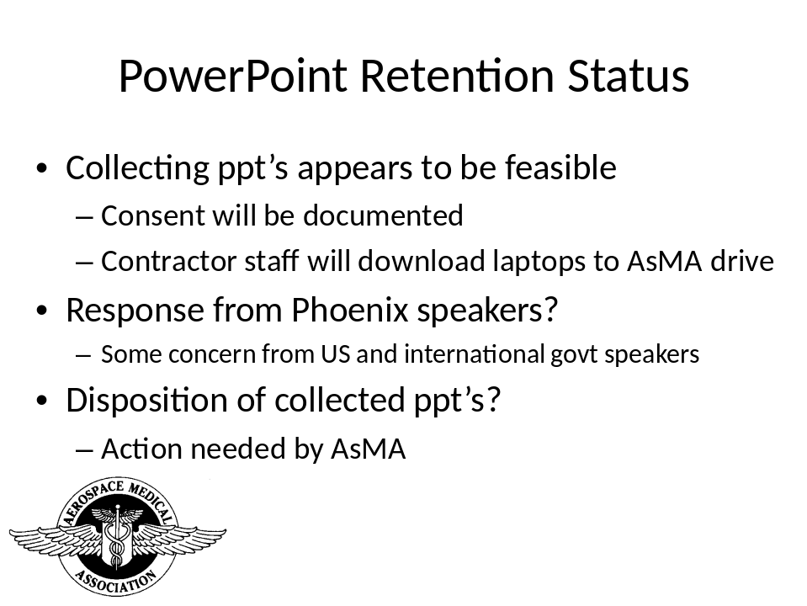

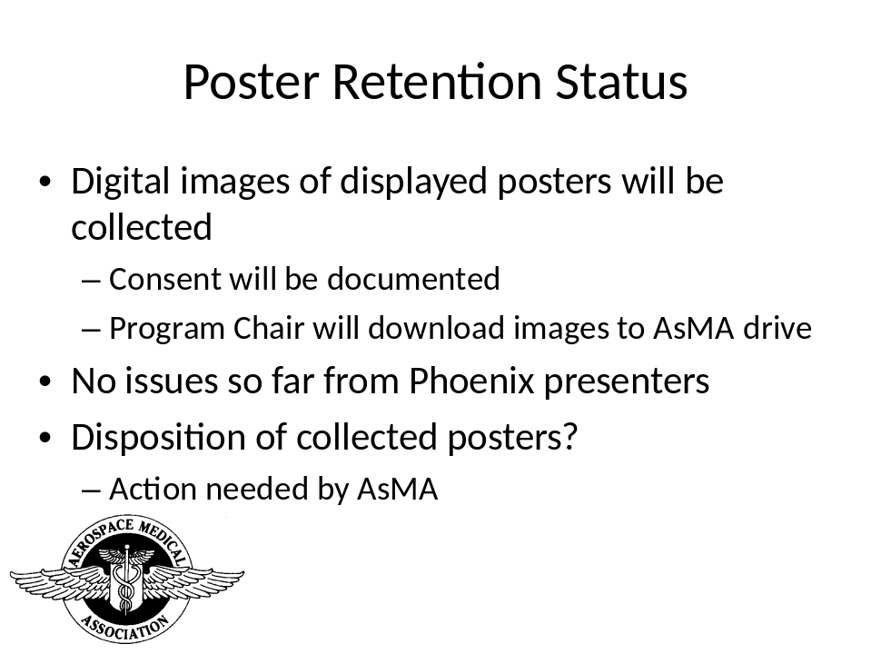

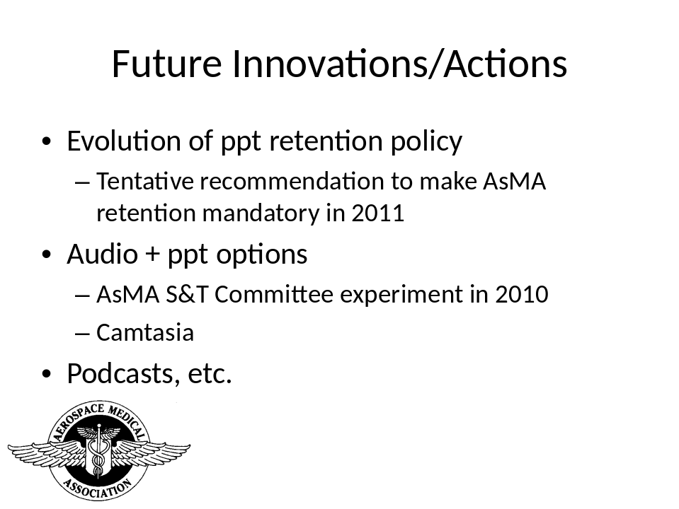

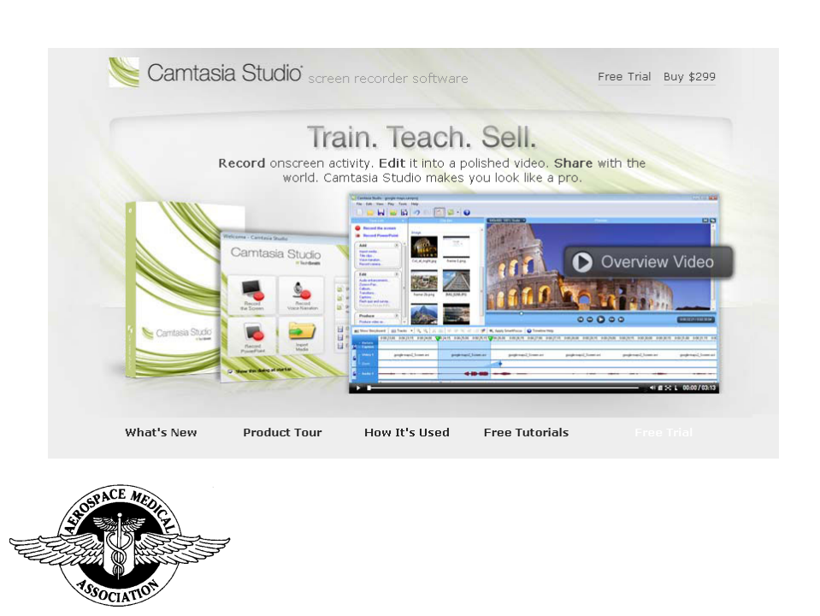

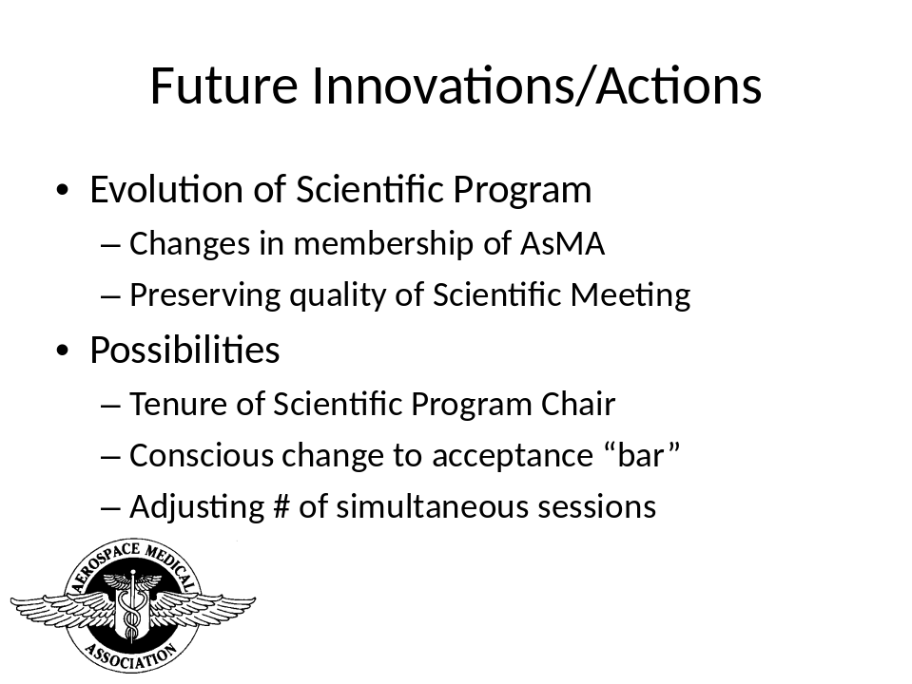
Aerospace Human Factors Committee Report
Aerospace Medical Association Council
May 9, 2010

Committee Chair: Thomas E. Nesthus, Ph.D.
Deputy Chair: Col. Donald J. White

Committee Activities since last report to Council:
- Midyear meeting in Alexandria VA attended by: L. Bailey, M. Cohen, J. DeVoll, C. Hackworth, R. King, M. Mallis, B. Musselman, T. Nesthus, D. Roberts, D. Schroeder, L. Tripp, and D. White.

- An update and discussion of AsHFC’s action list included the following:
  - Melissa Mallis’ briefing package on the AsMA Position Paper “Fatigue Countermeasures in Aviation” is now available for download from the AsHFA website.

  - “Emerging Trends in Aerospace Technology” – Briefly discussed our 3-yr plan. Discussion on updates and revisions were deferred until our May meeting.

  - “Advocate the Use of Aerospace Technologies”--Recognition was provided to committee members who had made contributions to the “S&T Watch Column” in coordination with the Science and Technology Committee. The 2009 published contributors included: James R. DeVoll, Biofilms and Aerospace Medicine ASEM 2009; 80:5 (May). Michael B. Russo, Melba C. Stetz, Craig M. Jenkins, and Ray A. Folen, Tripler Army Medical Center, Hawaii Armodafinil for the Treatment of Excessive Sleepiness ASEM 2009; 80:8 (Aug).

- Discussed coordination for the development of 3 HF panel sessions proposed for May, including:
- Sensorimotor Challenges of Space Exploration Missions, Chairs: C. Orman, J. Bloomberg
- Fatigue Risk Management Systems Parts I & II, Chairs: M. Mallis, L. Caldwell
- Flight Attendant Fatigue Parts I & II, Chair: T. Nesthus

- New Business: Introduced Deputy Chair, Col Don White who will take over as Chair during our meeting in May 2010.

Also, discussed ideas for program development for 2011 meeting in Anchorage, including:
- Traumatic Brain Injury—effects on performance, diagnosed or not
- Workload performance issues—Time-on-task and fatigue effects
- Medical procedures simulation & training
- Linking psychological performance with aviation performance

- Discussed liaison activities: attendees reported their contacts with other scientific organizations including DOD Human Factors Engineering Technical Advisory Group, Int’l Society of Aviation Psychologists, APA Divisions 19 (Military) & 21 (Applied Experimental and Engineering Psychologists), Human Factors & Ergonomics Society, and the European Association of Aviation Psychology.

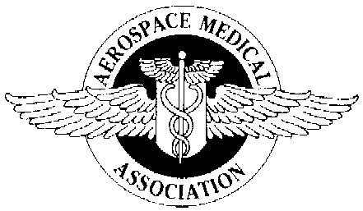Aerospace Medical Association

President
Robert W. Weien, M.D., M.P.H.
Colorado Springs, CO
Executive Director
Jeffrey Sventek, M.S.
Alexandria Home Office

320 South Henry Street
Alexandria, VA 22314-3579
Phone: 703-739-2240
Fax: 703-739-9652
www.asma.org

AEROSPACE MEDICAL ASSOCIATION
COMMITTEE REPORT
18 November 2009
Revised 2 May 2010

COMMITTEE NAME: Aviation Safety Committee
COMMITTEE CHAIR: Mary A. Cimrmancic, DDS
CIVIL AVIATION SAFETY SUBCOMMITTEE CHAIR: Ted Brook MD
MILITARY AVIATION SAFETY SUBCOMMITTEE CHAIR: Lt. Col. Karen Heupel, USAF
COMMITTEE MISSION STATEMENT: To promote civilian and military aviation safety research to benefit aircrews and passengers, and to improve aerospace systems performance.
MEMBERSHIP: The committee has 50 active members, 22 of which attended the 2009 Aviation Safety meetings.
COMMITTEE ACTIVITIES: The Committee has focused on the following activities since the May 2009 meeting in Los Angeles, CA:
- Position papers
- Civil Aviation Safety Subcommittee.
  - No position papers are currently active.
- Resolutions
  - No resolutions are currently active.
- Panels to be presented at the 2010 Scientific Meeting in Phoenix, AZ
- Aviation Safety Committee
  - Aviation Safety 2009 Year in Review. The Aviation Safety Committee will sponsor and chair an international panel.
    - Several Committee members will deliver presentations.
- Activity since 18 November 2009: Discussions for Proposed Panels and Position Papers for 2011
  - Aviation Safety Committee
    - Helicopter Emergency Medical Service (HEMS) operations. Examination of helicopter safety in MS and medical evacuation arenas; operational safety and risk assessment/management; human factors issues of operations into unprepared landing zones; Electronic Flight Information Systems; crashworthiness standards; potential HAZMAT issues for occupants and on-site accident investigators.
    - Potential for both Civil and Military Subcommittee participation, as well as collaboration with related organizations, including EMS and law enforcement. Consider as a means of AsMA membership recruitment.
    - (OPEN: Active, assignments pending.)
  - Civil Aviation Safety Subcommittee
    - Reference accident data of aircraft certificated under older Aircraft Specifications and Type Certificate Data Sheets (TCDS) versus newer TCDS for potential improvements in crashworthiness in the future. (OPEN: Maclarn, Cocks)
      - Examine related FAR Part 23 Revision as it progresses
    - Alcohol, medications and illegal substances in aviation. (OPEN: Assignments pending)
    - Survey of vision requirements in Civil Aeromedical Certification worldwide. Coordinate with Military Aviation Safety Subcommittee (OPEN)
  - Military Aviation Safety Subcommittee
    - Define top three priorities for military aviation safety. (OPEN)
    - Define top three priorities for Military color vision. Coordinate with Civil Aviation Safety Subcommittee. (OPEN)
    - Safety of military helicopter operations
      - Aeromedical evacuation – coordinate with Civil Aviation Safety Subcommittee. (OPEN: Assignments pending)

Education & Training Committee
Report to Council May 2010

Chair: Eilis Boudreau M.D., Ph.D.
Deputy Chair: Yvette DeBois, M.D., MPH
Summary and Status of Education & Training Committee Projects
(November 2009 – May 2010)
Issue | Update/Plans
“This is Aerospace Medicine” slide show | - Available for Council review & input.  - Mechanism for updates suggested.
Compendium of ASM Courses | - Quarterly Updates
MOC/CME Offerings | - Establish more formal working relationship with ASAMS (see attachments)  - ACCME Accreditation
Preparation of Material for Policy & Procedures Manual on Committee  Activities | - Dr. Lawrence Steinkraus appointed as E & T representative to Policy & Procedures Update Subcommittee of the Bylaws Committee.

- “This is Aerospace Medicine” Power Point Presentation
- Updates: Presentation available for review and committee approval.
- Plans: Implement proposed process for yearly reviews : January E & T Chair and at least one other E & T Committee member review the entire presentation for content and any major changes are submitted to Council for approval at the May annual meeting.
- Request to council: (a) Respectfully request approval of the content for this presentation. (b) Request approval for routine update process.

- Compendium of ASM Courses
- Update: Compendium is functional and quarterly updates are being made.
- Plans: Continue quarterly updates.
- Request to council: None at this time.

- Maintenance of Certification/CME
- Plans: See appendix for summary recommendations outlining how this committee will coordinate with the American Society of Aerospace Medicine Specialists (ASAMS) to support CME/MOC activities.
- Request to council: Respectfully request review and approval of attached document on CME/MOC activities.

- Preparation of Material for Policy & Procedures Manual
- Update 1: Completed brief write-up of committee activities to include membership, mission, and processes which was submitted for November 2009 meeting.
- Update 2: Dr. Steinkraus appointed as Education & Training Committee representative to the Policy & Procedures Subcommittee of the Bylaws Committee.
- Plans: Await input from Policy & Procedures Subcommittee of the Bylaws Committee.
- Request to council: None at this time.

Respectfully submitted,

Eilis Boudreau M.D., Ph.D.

MOC/CME Appendix
Background: Previous journal CME/MOC was underutilized and the cost of this program did not cover the association’s expenses to produce it.
Issues:
- Who should our target audience be for CME/MOC?
- Who should decide what CME/MOC content is needed?
- How should CME/MOC be delivered?
- Who will be responsible for generating CME/MOC content?
- Is partnering with other associations for CME/MOC viable at this time point?

Recommendations:
- CME/MOC target audience should be board certified aerospace medicine specialists. Rationale: Individuals boarded in other specialties are usually required to obtain CME/MOC from their home board and can’t use CME/MOC from other specialties towards recertification requirements. Boarded aerospace physicians need to have aerospace CME/MOC for recertification and generally do not have other aerospace specific sources to meet this need.
- ASAMS should decide on what content is needed and for generating that content with the assistance of the E & T Committee as requested by them.
Rationale: ASAMS represents the core boarded aerospace medicine specialist and is in the best position to decide what CME/MOC content and services their members require and will use.
- Ideally, MOC/CME needs to be available on-line through the AsMA website. We do not currently have this capability. Dr. Susan Northrup has MOC Part IV content ready to be posted. This will be posted on the AsMA website as a word document that will have to be downloaded, completed and then mailed back to her and her ASAMS team for payment, scoring and credit. While this is a good interim solution, long-term this is probably not viable, especially if further content is added.
- See point #2.
- Long-term we should still consider offering CME/MOC to other groups (eg. nursing, other specialty groups) and/or partnering with other associations to offer joint CME/MOC. However, my initial conversations with other associations such as the American Board of Preventative Medicine do not indicate that these joint CME/MOC projects are really viable at this time.

Summary: Boarded aerospace medicine specialists should be our primary target for CME/MOC services at this time as they require specialty specific content that is not provided by other associations. Furthermore, as the core services offered by this specialty are being eroded by other specialties (eg. airlines closing their medical departments and contracting services out to emergency room departments, internists) we need to help support the integrity of services offered by these specialist and help to protect the scope of the field.

Subject: History & Archives Committee Report
To: Executive Committee, AsMA
March 2010 Meeting, D.C.
From: Stanley R. Mohler, M.D.
Chair, H & A Committee
- The Committee initiative under the Reinartz Endowment has been facilitated by coordinative advice and suggestions by Genie Bopp. She is developing a schedule for digitally recorded interviews of senior AsMA members during the May 9-13, 2010 Scientific AsMA Meeting, Phoenix, AZ. She has also prepared a list of potential interviewers, each to be paired with an interviewee for the recordings. In addition, as previously reported, Genie arranged a telcon on June 18, 2009 with the Reinartz planning group and worked out a general approach to accomplishing the interviews and developing a structured outline for interviewers. A room has been identified by Jan Stepanek through arrangements with our home office at the Phoenix Sheraton Downtown during the above dates for the recordings as cited above. The H & A Committee coordinates with Mark Campbell and the Space Medicine Association with respect to interviewees of specific interest to their overlapping areas. Following the November 18, 2009, AsMA Council meeting, Alexandria, VA, an initial historical recorded interview was made by Mark Campbell interviewing Royce Moser, with recording by Jan Stepanek. Coordinated questions by Genie
Bopp were utilized.

- We are pleased that selections for the 2010 Phoenix meeting have been made for the popular noon time historical movies portraying aviation medicine aspects from decades past.
Cont.
These Hollywood preparations are from the extensive archives of Richard Jennings. The four are:

Mon May 10: “Gallant Journey” 1946 Glenn ford, et al.
Covers Meniere’s disease and fatal puncture of pilot’s
unprotected head in a crash.
Tues May 11: “Dive Bomber” 1941 Erroll Flynn, et al.
Describes early concepts of G-protective equipment.
Pilot fatigue measured by the “Schneider Index” is cited.
Wed May 12: “Appointment in London” 1952 Dick Bogarde,
et al. Perceptions by some of a “jinx” due to psychological
factors, fatigue and excessive alcohol intake, are dealt
with by a flight surgeon.
Thus May 13: “Fate is the Hunter” 1964 Glenn Ford, et al.
The cause of an airline pilot’s fatal crash is subjected to
a detailed investigation and the ultimate cause found is
surprising. Aeromedical and human factors aspects involved.
More details on the above films and the projection room will
be listed in the printed program.

- The Committee has identified several historical preparations reaching back to World War One. The Air Service Medical by The War Department, developed during WWI and lavishly illustrated, printed in 1919, GPO, 446 pp, and accompanied by a 2 hour 10 min film, is being reviewed for an airing at an appropriate venue. It shows candidates undergoing the rigorous new medical cadet examinations, flight training problems, and the new “Ruggles Orienter” proposed for flyer screenings. At the Los Angeles May 2009 AsMA scientific meeting, UltraThera Technologies, Inc., demonstrated an updated computer enhanced model, the AEROSTIM, with rides available in the exhibits area.
Cont.

The Committee has identified additional items reaching to WWII for subsequent airings. Consideration of these will be made at the May 2010 committee meeting in Phoenix.

- H & A Committee member, Robert Dille, has documented and published in 2009, an historical article that cites some serious medical problems (fatigue) and illnesses (dysentery) encountered by globe spanning women pilots during the 1930-67 time frame. For example, on September 25, 1930, Mildred Bruce departed solo from London, England, making multiple stops, including areas in India, Indo China and Japan. Her open cockpit biplane, a Blackburn Bluebird (with folding wings) was carried by the Empress of Japan from Tokyo to British Columbia. She flew to New York City (the NY postal covers are dated February 20, 1931). She and her plane were carried to France by the Ile de France. She then flew to Croydon airport, England, arriving almost five months after departing England. During the trip, exhaustion and dysentery were among the multiple challenges she encountered. For more details on this and certain other historical global flights as documented by primary sources, see Dille, J. Robert, “Covers Carried by Women Pilots on Round-the-World Flights, 1930-67,” Airpost Journal, June 2009, pp 235-245.

- The Committee will convene at 0700, May 11, during the Annual Scientific Meeting at the Sheraton Downtown Phoenix, in a room to be listed in the printed program.
Note: Interested persons are invited to attend.

Report to Council
Aerospace Medical Association
Science and Technology Committee
9 May 2010

Committee Name: Science and Technology
Committee Chair: Barry S. Shender, Ph.D.
Committee Mission Statement: To advance, foster and promote the role and
improved use of Science and Technology in attaining the goals of the Aerospace Medical Association

Committee activities since the last report to Council:

- The 2009-10 Committee consists of 30 members (one new).
- The Committee will have published 100 Science and Technology Watch columns in Aviation, Space and Environmental Medicine (with the help of Ms. Pam Day) as of May 2010. The Watch has served as a forum for members to introduce and discuss these new concepts. Since January 2009, columns are no longer part of the News section have been published in a format consistent with journal articles. Upcoming columns include:

  - Nanoparticle Toxicity (FEB 10)
  - Microfluidics Applications to Aerospace Medicine (APR 10)
  - The Use of “Virtual Reality” Sound Technology in Psychophysiological Sleep Enhancement Training Cell Phones as a Mobile Medical Platform (MAY 10)
  - Systems Biology in Aerospace Medical Research (JUNE 10)
  - Real-world attenuation of foam earplugs (JULY 10)

- The Committee has organized / co-sponsored four panels for the 2010 Scientific Program:
- Critical Decision-Making In Dynamic Operational Environments at 1600 on Tuesday 11 May in the Encato Room (organized and chaired by David G. Newman, DAvMed, PhD, Thomas E. Nesthus, PhD):
  - Critical decision-making in dynamic operational environments
  - Airline operations control: What is it? What does it do? Why is it important?
  - Airline operational disruption management: Why am I late? Why is my flight cancelled?
  - Fatigue risk management in crew pairing & rostering
  - Fatigue risk management in crew tracking
  - Coordination of air traffic control procedures on September 11, 2001

- Telemedicine Innovations Supporting Aerospace Medicine Requirements at 14:00 on Wednesday 12 May in the Camelback room (organized and chaired by James McGhee):
  - Application of space technologies in ehealth care on earth
  - Telemedicine in U.S. Navy aircraft carrier strikegroups
  - NASA-Navy telemedicine: autogenic feedback training exercises for motion sickness
  - Multisensory augmentation of telemedicine systems
  - Robotics and unmanned systems – “game changers” for medical missions

- Effects of Gender on Dynamic Loading Response on Monday 10 May at 10:30 in the Alhambra room (organized and chaired by Barry S. Shender, PhD). Co-sponsored by Life Sciences and Biomedical Engineering Branch:
  - Are women just small men? the effect of gender on human response to impact
  - Gender differences in the geometric and inertial properties of the adult human head
  - Role of gender-dependent neck muscle anatomy on head-neck stability
  - Gender bias in lumbar spine spondylolisthesis: a possible biomechanical etiology
  - Gender-based differences in kinematic response to the catapult phase of ejection
  - Determining the effects of gender on the probability of injury during ejection using a parametric, probabilistic, finite element cervical spine model

- User-centered Measurement of Cognitive Workload: What Does the Customer Want? At 10:30 on Wednesday 12 May in the Camelback room (organized and chaired by Valerie Martindale). Co-sponsored by Aerospace Human Factors:
  - Helicopter aircrew workload for manned-unmanned teaming
  - Measurement of cognitive workload: Overview of research at TNO Human Factors
  - Individual differences in multitasking performance and effects of imperfect automation
  - Shaping factors of cognitive workload – ecological research from operational environments
  - Is measurement of cognitive workload the right target? An approach using central general systems performance theory

- Following direction from the November Council meeting, it was agreed that PowerPoint presentations at the end of each session at the May 2010 Scientific Meeting will be collected for later sale / distribution. The S&T Committee will coordinate with the Program Committee to assist in this process.

  - The new procedure was included in the abstract acceptance letter
  - AIM will collect the PowerPoint presentations at the end of each session for later processing
  - To protect author’s IP, PPT will be converted to protected PDF and watermarked
  - All presentations should already be cleared for unclassified international audience. However, authors who do not wish to participate can opt out
  - Create a hyperlinked directory to organize the PPT; by session, author, topic area
  - Deliver the product via web with secure payment for on-line delivery
  - This involves collecting and selling session presentations; Council action to decide process

Respectfully,
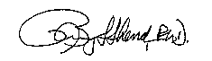
Barry S. Shender, Ph.D.,
Chair, Science and Technology Committee

Current membership list:
Col Richard E. Bachmann, Jr., USAF, MC, CFS (NEW)
Col John V. Barson, MC, USA (retired)
Dennis Burian, Ph.D.
Tamara Chelette, Ph.D.
John Crowley, MD MPH
Dr. James R. DeVoll, MD, MPH
Estrella M. Forster, Ph.D.
William Fraser
Alex Garbino
John Gibbons, Lt Col, USAF, MC, SFS
Leonid Hrebien, Ph.D.
Francis S. “Ted” Knox, III, Ph.D.
Doris M. Kupfer, Ph.D.
Carol Manning, Ph.D.
Valerie Martindale, LtCol, USAF BSC
Mydin Meer Ahmad Lt Col (Rtd)
Nelda J. Milburn
Thomas E. Nesthus, Ph.D.
David G. Newman, MB, BS, DAvMed, Ph.D.
Pamela Novy
Derek Nusbaum
Felix Porras, MD
Marc Robins, DO, MPH
Paul Rogers, M.S.
Michael B. Russo, MD, FS, FAAN, FAASM
David J. Schroeder
Barry S. Shender, Ph.D. (CHAIR)
Dr Bhupi Singh, MD, FACMS
Stephen J. H. Veronneau, M.D.
Deborah White, Ph.D.

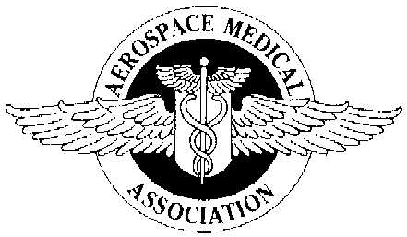

AsMA Council Meeting

May 9, 2010

Comparison statistics for the periods 1 January, 2008 through 1 January, 2009 and

1 January 2009 to 1 January 2010.

1 January 2008 - 1 January 2009

Membership 1 January, 2008 = 2,814
Membership 1 January, 2009 = 2,770

STATISTICS: (Jan. 08 Jan. 09
New Members 322
Reinstates 84
Gains 406

Delinquents 415
Resignations 20
Deceased 15
Losses 450

1 January 2009 - 1 January 2010

Membership 1 January, 2009 = 2,770
Membership 1 January, 2010 = 2,834

STATISTICS: (Jan. 09 Jan. 10)
New Members 286
Reinstates 59
Gaines 345

Delinquents 260
Resignations 11
Deceased 10
Losses 281

The membership of the Aerospace Medical Association consists at this time of 208 Student /Resident
Members; 649 Three Year Memberships; 252 Life Members; 46 Corporate Members; 1,084 Active Members; 47 Member and Spouse Memberships; 452 Emeritus Members; and 12 Sustaining-Technician Members, which gives a current membership total of 2,750

For our Phoenix 2010 Annual Scientific Meeting we have “Advanced Registered” a total of
1,007 registrants, 35 Exhibiting Companies with a total of 41 booths.

Sincerely,

Gloria M. Carter
Director, AsMA Membership

Aerospace Medical Association

President

Bob Weien, M.D., M.P.H.
Colorado Springs, CO

Executive Director
Jeff Sventek, M.S.
Association Home Office

23 Feb 2010
Jeff Sventek
Executive Director
Aerospace Medical Association
320 S. Henry Street
Alexandria, VA 22314-3579

The Awards Committee has completed its review of the nominations submitted for this year. We are pleased to recommend the following individuals to receive the 2010 Aerospace Medical Association Awards:

Louis H. Bauer Founder's Award Melchor Antunano
Mary T. Klinker Award Eleanor Jarrett
Harry G. Moseley Award Susan Baker
Eric Liljencrantz Award Larry Krock
Theodore Lyster Award Warren Silberman
Boothby-Edwards Award Dougal Watson
Julian E. Ward Award Kevin Bohnsack
Raymond F. Longacre Award Norbert Kraft
John A. Tamisiea Award Guillermo Salazaar
John Paul Stapp Award Bob Banks
Kent K. Gillingham Award Brian Self
Won Chuel Kay Award Goeff Caine
Marie Marvingt Award Anthony Tvaryanas
Arnold D. Tuttle Award Desmond Connolly & John Barbur (co-authors)
Sidney D. Leverett Award Valerie Martindale
Two New Awards:
Joe Kerwin Award Michael Barrett
John Ernsting Award Frank Pettyjohn

Plan to present Dr Nigel Dowdall with a Special Plaque of Thanks from the Awards Committee for his service as the Tuttle (Best Paper in ASEM) sub-committee Chair for many years. This is a difficult and unsung type of job, and he has done an exceptional job at it.
Tuttle Paper Title: “Low Contrast Acuity at Photopic and Mesopic Luminance Under Mild Hypoxia” Nov 2009 (933-940)

These are submitted for review and approval by the Executive Committee.

Respectfully submitted,

//signed// Dwight Holland, MD, PhD
--submitted from USAF Test Pilot School; Edwards AFB, CA

Chair, Awards Committee

COUNCIL MEETING
AEROSPACE MEDICAL ASSOCIATON
MAY 9, 2010
SHERATON PHOENIX DOWNTOWN HOTEL
PHOENIX, AZ

MEMBERSHIP COMMITTEE REPORT

The Membership Committee continued its traditional work of reminding members about renewing their membership with the Association. In addition, we had several initiatives that started, some via the ad hoc Membership committee and some via the regular contributors (meaning Dr. Myers, mostly). The following items are significant events for 2009 – 10.
Dues structure was examined and Council established policy on this at the November meeting (see dues and reports from Nov 09).

Committee reviewed the membership survey from 2006. Recommended repeating the survey with few modifications. We are proposing adding only one more question. We will analyze the results in comparison to the 2006 survey results. This effort may help us focus targeted actions on specific membership groups. The survey will be conducted from June to Aug 2010. Results will be presented in November. Findings will be passed on to the Membership Committee to develop a membership incentive action plan.

As mentioned Dr. Myers continued our direct membership actions by sending individual email reminders to recently non-current members. These personal emails were to remind our peers that their dues to the Association were lapsing. While we have not studied the overall responses to these emails, we generally believe them to be relatively effective. Currently each committee volunteer simply sends a few emails each month. But given the state of modern information technology and the improvements recently made by the home office, perhaps this function might be considered for automation.

We further propose to increase our efforts from the traditional “get out the dues” campaign from delinquent membership to some new areas focused on several specific groups.

Directed Constituent Organization services: Most if not all of our members join AsMA via a constituent organization early in their careers. But it is typically after attending several AsMA Annual Meetings that they understand the true scope of Aerospace Medicine (AsM) and power of the relationships available in AsMA. We should insure that our constituent member organizations can remain viable. If they have membership issues, then AsMA has membership issues. Marian Sides has worked individually with the Aerospace Nursing Society on their membership problems. Many others have contacted me about linking financial and IT services with the home office. Most would be willing to pay some sort of fee for these synergies. Thus, this committee would like to act as a liaison to the Exec Council for these organizations. To that end I would like begin to change the structure of the committee to include the named “membership” individuals for each constituent. This year will be critical to get the proper requirements gathered for linking our key constituents to the home office IT efforts.

Directed New Member actions: With the above structure, we can then gather and work on directly recruiting new members. Each of our constituent organization has knowledge of the training required to enter that career. Thus, we wish to gather a list of all known training courses related to AsM. From this list we would request that AsMA send a personal letter to each class graduate making him or her aware of the opportunities that membership in AsMA affords. We could also perhaps indicate how important AsMA views their course of study by offering the distinguished graduate some sort of complimentary membership, presented by an AsMA member. Some organizations do this (SOUSAFFS, SOUSNFS) but we would propose to track membership rates of graduates from all courses. Perhaps some competition might improve membership rates. We are considering developing a “top 10 reasons to join AsMA” brochure or webpage for this use.

Directed meeting attendee actions: Annual meeting attendance is the lifeblood financially of the Association. While there are many avenues to investigate here, the Membership Committee would like to look at a specific subgroup – non-member attendees. Earlier trial rate proposals were not adopted by the organization, but this specific subgroup might be a more appropriate target group. Since they do make us more money at the annual meeting, any efforts at membership would be looked at carefully. This action would simply be to study this particular group of associates of AsMA.

Recommendations: The ad hoc committee recommends that we focus on member services and strengthening member satisfaction within AsMA. We will conduct a survey of our membership. A survey instrument will be designed. A stratified, representative sample (300 members) will be selected to participate. Data analysis will determine the top areas of interest, needs and desires of our members and will determine what they value most in their membership with AsMA.
Additionally, we strongly urge that the Council consider utilizing the Constituent Organizations more robustly and also including their IT and financial requirements under the parent organization umbrella. The Membership committee will continue to work all avenues to increase Association membership and member participation. We would request widest support for each constituent organization to place its membership representative on AsMA’s Membership Committee. We will further continue to report results and recommendations up to the Council for consideration.

I wish to acknowledge and thank my core committee members for their work and participation over the past year. They are Christopher Borchardt MD, Mark Edwards MD, and Jeff Myers MD. In addition, I thank Dr Rayman, Ms Gloria Carter and the home office staff who provided data, and numerous AsMA members provided valuable input on the issues.

Respectfully submitted,

H. J. Ortega, Jr. MD, MPH
Col USAF MC CFS
Fellow, AsMA

Aerospace Medical Association
Corporate Sustaining Membership Committee
Fourth Quarter Report
May 8, 2010
Chairman: Yvette DeBois, MD MPH
Deputy Chairman: Not Designated
Primary immediate objectives for the Corporate & Sustaining Membership Committee (CSMC) this cycle include:
- Standardizing the process of New Member Solicitation with incorporation of the AsMA Home Office resources
- Supporting the 7 Benefits of Affiliation for the Corporate & Sustaining Affiliate (CSA) members with an emphasis on Advocacy and cultivating Leadership
- Developing infrastructure geared for independent function of CSA with special emphasis on financial support of operations and functional presence on the worldwide web
- Supporting CSA leadership in preparation for the historic event of their first annual business meeting/luncheon
Membership & Member Services
The CSMC recognizes 45 corporate members with new members at the conclusion of this cycle including Advitech Inc., Center for Disease Control (Alaska), Highbury Consulting Ltd., Inomedic Inc., Infoscitex, Psoria-Shield, Inc. and a renewal of membership, Pilot Medical Solutions. Drs. Christopher Borchardt and Walt Dalitsch, as well as Jeff Sventek, MS should be recognized for their assistance in recruitment efforts this cycle in engaging 17 organizations in meaningful membership conversations. The Committee acknowledges and thanks Dr. Rayman for agreeing to assume the mailing responsibilities for this task. The Committee additionally reports three losses over the cycle with one additional potential loss pending, however the Committee expects successful recruitment through the Corporate Forum during the Phoenix scientific meeting.
Dr. Yvette DeBois continues to model the role of Affiliate Membership Chairman for CSA. Needs Assessments have been held in abeyance for the Phoenix Corporate Forum, as many of our potential members plan to attend this function. A Solicitation Guide, Needs Assessment Guide, and the CSA Benefits of Affiliation have been posted to the C&S restricted access site of the AsMA website to facilitate CSMC, CSA, and the Home Office Staff working in concert on solicitation issues. The 2008 Corporate Forum slides have been provided for the Home Office to use for full-time staff training related to corporate membership. Additionally, the Affiliate directory has been updated to reflect a Primary Representative, Alternate Representative, and Billing Contact for each corporate member to promote continuity and augment member involvement.
The Corporate Forum, a program designed to assist members in optimizing the benefits of affiliation traditionally conducted in November, has been moved to the May venue. This change is anticipated to broaden the audience, exposing exhibitors, as well as members, to these benefits. To date, an unprecedented 15 corporate members and 7 exhibitors have reserved a seat at the Forum. Speakers include Drs. Guy Banta, Andrew Bellenkes, Dan Callan, Yvette DeBois, and Marian Sides, and they will be joined by Drs. Eilis Boudreau, Margaret Matarese, David O’Brien, Paul Young and Ms. Janet Sanner to conduct Needs Assessments at the conclusion of the Forum.
Plans for web presence for the Affiliate were held in abeyance for the reassessment of the capabilities of the new AsMA site and for more information regarding Affiliate attitudes toward options to finance web presence subsequently obtained through the CSA 2010 Action Survey (discussed below). CSMC will continue to provide support in the development of functional, secured web presence to the Affiliate. The CSMC appreciates the efforts of Rachel Trigg in posting some of the requested revisions designed to streamline corporate member applications and augment member use of the current AsMA website.
The CSMC is developing programming to better connect the exhibiting experience to actual marketing benefits. Volume 7 of the CSA Courier was distributed last November with feature article contributions from Drs. Guy Banta (Eagle Applied Sciences), Christopher Borchardt, Eilis Boudreau, Marian Sides (Education Enterprises) , Joan Vernikos, and Robert Weien . Dr. Yvette DeBois served as Chief Editor for the issue and final formatting assistance was provided by Dr. James DeVoll. The CSA Courier is scheduled to be transferred to Affiliate management in this upcoming cycle.
One issue has been formally presented for advocacy by the Primary Representative from United Airlines, Gordon Landsman, MD. After conferring with selected airline medical directors via teleconference, Dr. Russell Rayman will be meeting with them to consider recommendations for Association action on this matter. To augment awareness of this crucial issue the CSMC is assisting CSA in producing a feature event during their first annual Business Luncheon, a panel discussion, “Challenges Facing US Internal Airline Medical Departments Today”.
Teleconference calls amongst CSMC members most consistently contributing to long-term planning for the Affiliate revealed a need to better characterize corporate members values. Additionally, the Home Office requested that the Committee gauge plans for attendance to annual meeting planned events. So, an electronic survey of questions designed to:
- Assess Perceived Value for Benefits of Affiliation
- Encourage Participation and Leadership Amongst Corporate Members
- Evaluate Level of Member Interest in Key Programs and Initiatives for 2011 Planning
- Gauge Planned Attendance to 2010 Meeting Events
was administered to the Primary & Alternate Representatives of the 44 corporate members. Responses were collected over one month and garnered opinions from 55% of the member companies. Highlights of the attached findings include:
- All of the Benefits of Affiliation were valuable to the responders with Networking garnering recognition by 88.5% of responders.
- Members have demonstrated interest and commitment to participate on all of the Committees, Initiatives, and programming established through infrastructure created by the work of the CSMC.
- The CSA Courier has utility for most members, but commitment to submit articles, etc. is not at a level that will support its development solely from their efforts at this time.
- One third of the member companies committed to assisting AMSRO through sponsorship of their Scientific Paper Award or assistance in the development of a business model for student and resident recruitment. Another 20% reported being unable to support AMSRO at this time despite the consistency of these efforts with their organizational goals.
- The responses indicated overwhelming support for an independent website for the Affiliate, but also generated concerns for its financing.
- Responses indicated that a dues increase to cover innovations in the newsletter, an independent website, and augment programming would garner a lack of support at this time.
Transition Program
This year begins the transition of some pivotal functions being modeled by CSMC members in recent years to CSA. Though the History Initiative, Philanthropic Initiative, and Speaker’s Bureau have been transferred to the CSA for development and management, the CSMC still provides conceptual guidance for the History Initiative Workgroup regarding data base contents, data entry and quality control management, and technical interface issues. Dr. Banta has appointed Deborah Lickteig to head this workgroup. The next function planned for transition to the CSA within the 2010-11 cycle for development and management is the newsletter, The CSA Courier.
Modeling the role of Affiliate Nominating Chairman, Dr. Dan Callan assists CSA in identifying members for key Affiliate leadership positions. Most notable amongst these efforts is the designation of the CSA President-Elect, Dr. Guy Banta from Eagle Applied Sciences, LLC. Dr. Callan provided support for the Affiliate’s first election. Results of the process will be announced at the first CSA Business Luncheon, an historic milestone for the Affiliate with a feature event discussed below, on Monday, May 10th at noon.
Additionally, Dr. Callan’s report, reflecting the operating costs for CSA annually, was updated this past November. This data has been gathered to prepare the Affiliate and the Association for a more accurate picture of expenditures for operations. Costs within the report include solicitation and needs assessment expenses, as well as those associated with annual scientific meeting programming. Assistance from the Home Office with mailings for solicitation this year should acknowledge the support of Russell Rayman, MD from the AsMA Home Office, off-setting costs for this specific function.
Many of these costs over the years have been assumed by Education Enterprises, Inc. and various CSMC members. While having the benefit of requiring no supplemental funding from the Association or other corporate members for this seamless extension of member services, this funding methodology neither encourages broad-based ownership of the Affiliate and its functions, nor promotes transparency and practicality amongst corporate members or the Association regarding appropriate provisions for services rendered to provide the benefits of affiliation promised through corporate membership. Most affiliate and constituent organizations cover operating expenses through dues. Though CSA is a recognized affiliate of the Association, the collection of Affiliate dues, given corporate Association membership dues and corporate contributions to the annual meeting activities, has the potential to negatively affect retention. The CSA 2010 Actions Plan Survey results related to this issue (discussed above) indicate a lack of support for a dues increase for augmentations in programming, simultaneously however there is considerable support for specific organizational (functional) features, such as an independent website. Moving the Affiliate to independent, sustainable status without curtailing programming viewed by Corporates as member services will require cooperative planning, guidance, and commitment from the CSMC and Council in this upcoming cycle.

Programs

Dr. Eilis Boudreau continues to model the role of Affiliate Program Chairman and is charged with progress of the Core Curriculum and subsequent panel sponsorship. The CSA 2010 Action Plan Survey indicated a considerable number of members interested in functioning on the Program Committee. The Aerospace Nursing Core, the Hyperbaric Medicine Core, the Occupational & Environmental Medicine Core, and the Sleep subcore under the Clinical Aviation Medicine Core are currently in development with major contributors including Drs. D.K. Broadwell, Dan Callan, Yvette DeBois, Catherine DiBiase, Janet Sanner, Marian Sides, and Paul Young . Additionally, the Affiliate will be sponsoring one panel, consistent with their continued support of topics less commonly included in the scientific program. Chaired by Dan Callan, DO MPH and Bruce Bohnker, MD MPH, Mitch Garber MD MPH MSME joins the panel composition to discuss medical standards in various forms of transportation in this panel with lessons for air and space travel in “Beyond Things with Wings” in the Estrella Room in the Downtown Phoenix Sheraton on Monday, May 10th at 4:00pm.

Corporate & Sustaining Membership Committee
Of the
Aerospace Medical Association
CSA 2010 Action Plan Survey Results

Survey Goals
- Assess Perceived Value for Benefits of Affiliation
- Encourage Participation and Leadership Amongst Corporate Members
- Evaluate Level of Interest in Key Programs and Initiatives for 2011 Planning
- Gauge Planned Attendance to 2010 Meeting Events

Survey Sample & Response Rate
After receiving the latest Courier, survey links were distributed via SurveyMonkey to the Primary & Alternate Representatives of all active member companies (68). Thirty partial and total survey responses were received, representing 24 of the 44 member companies.
Responding companies: Advitech, ALPA, American Airlines, AOPA, Autoflug, CDC, Dowling State College, Eagle Applied Sciences, Education Enterprises, Egyptian Aviation Academy, ETC, Federal Express, Harvey Watt, Infoscitex, JALI, Lifeport, Mayo Clinic, Oregon Aero, Sanofi-Aventis, South African Airlines, Sperian Eye Protection, United Airlines, Virtual Flight Surgeons, Wyle (Responses related to meeting attendance are not included in this report.)

Survey Results
Benefits of Affiliation – Perceived Value
Q: Please, indicate the Benefits of Affiliation with AsMA that your organization most values. Please, indicate all that apply.

AsMA Corporate Benefits of Affiliation - Values

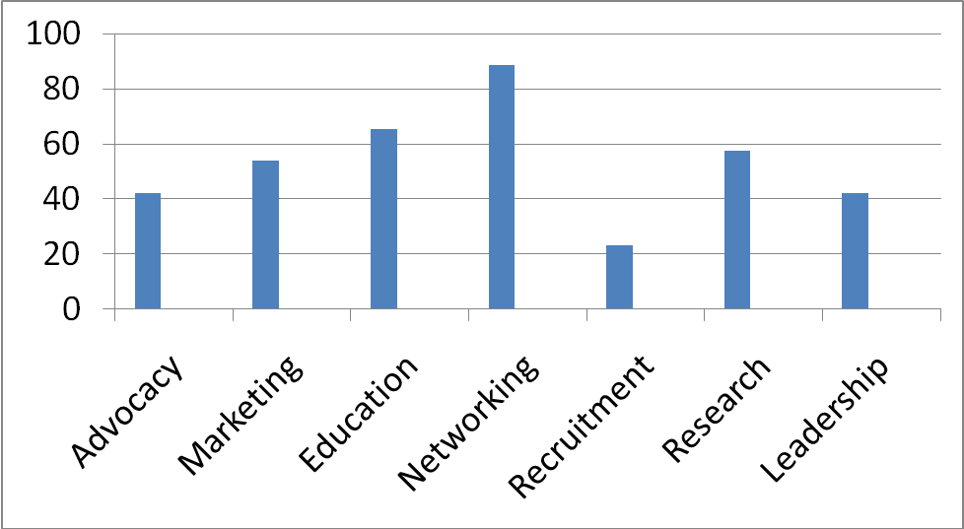
Networking was the most valued benefit of affiliation amongst responders (88.5%), followed by Education (65.4%), Research (57.7%), Marketing (53.8%), Advocacy & Leadership (both 42.3%), and Recruitment (23.1%).
Member Company Participation

Responses indicate that committees, initiatives, and programs, the infrastructure created through CSMC work, was of interest to a considerable number of responding corporate members. They committed to participation in the 2010-11 cycle with most frequently indicated activities for involvement including the Exhibitor’s Program & Program Committee. Response data embedded into survey options in Blue Text below.

Q: The Nuts & Bolts column of the CSA Courier provides background information on the activities of the Initiatives and Committees within CSA. Your involvement in these activities is necessary to continue progress and guide AsMA regarding issues that face our industry. Please, indicate activities to which you or your designee would like to contribute that may simultaneously address the needs of your organization. You may learn more about each of these activities in the Nuts & Bolts section of your latest CSA Courier. Please, indicate all that apply.
History Initiative (18.2%/4 Companies) - Participants on this workgroup are interested in preserving and sharing the rich history of corporate involvement in AsMA. The workgroup is currently creating a searchable database for corporate members and the Association at large. Participants are seeking assistance to make decisions on parameters of interest, financing, and implementation.
Philanthropic Initiative (9.1%/2 Companies) - Participants on this workgroup create venues to highlight the philanthropic efforts of all the corporate members and opportunities for unified charitable giving. They are currently seeking assistance in gathering information on the giving activities of each corporate member.
Finance Initiative (9.1%/2 Companies)- This initiative is laying the groundwork for the CSA Finance Committee, by quantifying support necessary to conduct CSA's fundamental initiatives and programs. The workgroup seeks interested members to form a formal committee for ongoing planning.
Exhibitor’s Program (54.5%/12 Companies) - This workgroup monitors the annual meeting exhibits to ensure that the experience provides a valuable opportunity for participants to augment visibility, network, and recruit. They are seeking members to join them in Phoenix to greet the 2010 annual meeting exhibitors and create venues to evaluate their experience.
Membership Committee (27.3%/6 Companies) - This committee is the oldest of the standing committees of the Affiliate, the hub of operations. It works closely with the Corporate & Sustaining Membership Committee (CSMC) on new member solicitation, member retention programs, the newsletter, the website, issues for advocacy, the Exhibitor's Program, as well as the History, Philanthropic and Finance Initiatives. Members are needed to participate in programming design to fortify current functions to ensure meaningful growth of CSA.
Program Committee (45.5%/10 Companies) - This committee is charged with support for annual meeting submission, research sponsorship, the development of the Core Curriculum, and the annual Speakers Bureau. Participants work with the Corporate & Sustaining Membership Committee (CSMC) to select annual meeting research for sponsorship through Core Curriculum development, coordinate international research efforts, and produce the Speakers Bureau event. Members with an interest in research, scientific development support, and topical industry developments could contribute significantly to this standing committee.
Nominating Committee (18.2%/4 Companies) - This committee is currently developing a slate for the planned 2010 elections. Members with ideas to contribute to the functions of the Affiliate through officer and committee chair positions are welcome here.
CSA Forum (22.7%/5 Companies)- The Corporate & Sustaining Membership Committee (CSMC) with the AsMA Home Office have been conducting an annual program to highlight the benefits of affiliation for new and prospective members. Members are encouraged to attend and veteran members are invited to participate in the next Forum conducted on Sunday, May 9, 2010 in Phoenix after exhibits are set up.
CSA Newsletter (31.8%/7 Companies)- The CSA Courier is the Affiliate's primary publication, designed to showcase member achievements, update Affiliate activities, and provide connectivity to key functions of the Association. The Corporate & Sustaining Membership Committee (CSMC) provides support for Affiliate members to submit needed feature stories and standing columns.
CSA Website (27.3%/6 Companies) - The Corporate & Sustaining Membership Committee (CSMC) has been working on text for the new website that will be a virtual gathering place for networking and work product for CSA. Members are requested to join this workgroup that is addressing the details of formatting, hosting, servicing, and financing this site.

Newsletter
Utility
Amongst the responders, 62.1% reported reading the latest or a previous issue of the newsletter, and 37.9% reported not reading the latest or previous issue of the Courier.
Q: Have you read the latest or a previous issue of our newsletter, The CSA Courier, to update yourself on the activities of your fellow organization members and the CSA?
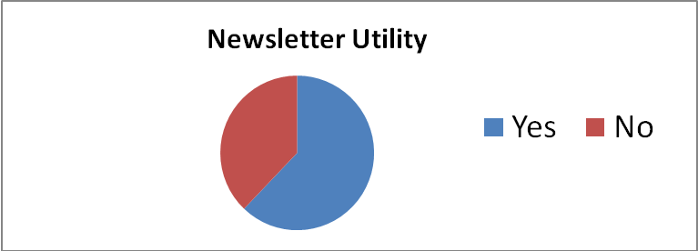
Participation & Subscription Support
Amongst responders, 19% indicated that they planned to submit entries for the Courier in 2011, while 14.3% indicated they did not plan to submit entries for the Courier in 2011. When asked whether they would support a subscription service to expand articles within the Courier or other AsMA publications to include more aerospace commerce information, they overwhelming responded (67%) that they had not explored the Courier enough to recommend/not recommend subscription service support. 4.8% of responders were in support of a subscription service to expand articles within the Courier or other AsMA publications to include more information of interest to aerospace commerce, while 4.8% were not in support of a subscription service to expand articles within the Courier or other AsMA publications to include more information of interest to aerospace commerce.

Professional Development Initiative
Thirteen companies indicated plans to assist the Aerospace Medicine Student & Resident Organization (AMSRO) by providing guidance in the development of a business model for recruitment and/or sponsor their Scientific Paper Award. Though several companies (10) declined to be involved with either effort, they indicated that the Initiative was consistent with their overall organizational objectives. Only 2 companies declined, because the Initiative was inconsistent with their organizational goals. So almost 30% of the members committed to assisting AMSRO in these functions and another 20% reported these functions consistent with their organizational goals.
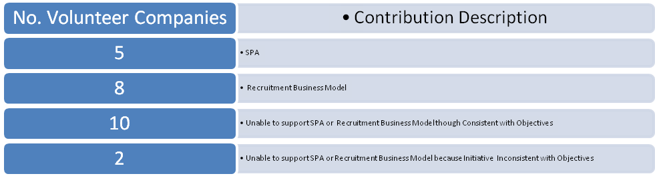

CSA Website Development

Amongst responders, 38.1% indicated support for a modest increase in dues to create an independent website for CSA, while 28.6% were in support of the independent website, but did not support a modest dues increase to support it. Additionally, 28.6% of responders indicated that they were not in support of an independent website for CSA members and one company indicated support of the independent website, but not the modest dues increase because it would be interested in partially or completely financing the site.

Finance Initiative
To cover innovations in the newsletter, an independent website, and augment programming options for CSA, 23.8% of responders indicated support of a dues increase with another 14.3% in support augmenting funds for these purposes but also indicating inability to comply with a dues increase or contribute to an independent treasury. However, 61.9% indicated that they were not in support of augmented funds to cover these costs.

Conclusions
CSA members appreciate the benefits of affiliation as developed in recent years, with Networking most consistently reported as valuable. Through recent actions taken by the CSMC to provide advocacy, collaborative opportunities including work on the Core Curriculum, and the development of the Corporate Forum, as examples, new ways for corporate members to meaningfully interact, i.e. network, are developing. The activities for involvement attract the full range of organizations with the Program Committee and Exhibitors Program generating the most interest. These results are consistent with the response distribution in the question designed to assess value of the Benefits of Affiliation. The Courier is the next function to be “transitioned” to the Affiliate. The membership is reading the newsletter, but only 20% have plans to contribute for the 2010-11 cycle. More involvement in feature and standing column writing amongst the membership will be needed for the newsletter transition to be effective. Supplemental subscription to a service to enhance its content was an option that the responders felt unable to assess at this time. These services were being considered as tools to contribute to feature columns to assist the Affiliate in assuming full responsibility for the Courier’s production and distribution. A considerable number of members have an interest in supporting AMSRO initiatives this year through the development of a recruitment business model and through SPA sponsorship over the next few years. A considerable percentage of responders (>70%) indicated support of an independent website for CSA, but many indicated that they would not support a modest dues increase to finance it. Still nearly a third of the responders indicated not supporting an independent website for the Affiliate. Clarity on this issue may be elusive, because the members at large cannot envision the benefits of a functional website, as this function has not been modeled for them to date. The responses to the finance initiative are most likely reflecting of the general corporate economic climate at this time and would suggest dues increases even for innovations to support the Affiliate will not be well received.

Air Transport Medicine Committee

Report to AsMA Council

May, 2010

Committee Name: Air Transport Medicine
Committee Chair: Nigel Dowdall, MBChB
Membership Demographics: 37 active members

Committee Activities: The committee has focused on the following activities since the last report to Council in Nov 09:
- Cabin air contamination. Several committee members are active participants in the research sponsored by the UK Dept for Transport. Results from the first phase of the research are anticipated later this year.
- Cabin crew medical fitness. The European Aviation Safety Agency (EASA) has published proposals on cabin crew medical fitness requirements. Members of the committee have been active in responding to the proposals. EASA is still reviewing the responses.
- WHO Review of chemicals for aircraft disinsection. AsMA was invited to comment on DRAFT Generic risk assessment model for aircraft disinsection with chemical insecticides. ATM was tasked with submitting a draft to the Executive Director for subsequent review, comment and approval by ExComm. Task completed.

2010 Annual Scientific Meeting:
Presentations and panels: The following panel will be sponsored at the 2010 Scientific Meeting:
- H1N1 and other communicable diseases in air travel.

Committee Chair:
In Jan 2010 I advised that due to changing personal circumstances I wished to resign from the role of Committee Chairman, with effect from the May 2010 Meeting. At the time of compilation of this report, the new Chair had not been nominated.

Respectfully submitted,

Nigel Dowdall
Air Transport Medicine Committee Chairman

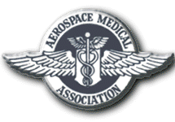
Aerospace Medical Association
320 South Henry Street
Alexandria, VA 22314-3579
Phone: 703-739-2240
Fax: 703-739-9652
www.asma.org

AEROSPACE MEDICAL ASSOCIATION
COMMUNICATIONS COMMITTEE REPORT, MAY 9, 2010

COMMITTEE NAME: Communications Committee

CHAIR: Joe Dervay, MD

GOALS: To improve communications between the membership, organizations, and headquarters of the Aerospace Medical Association (AsMA), as well as externally.

ACTIVITIES/ISSUES:

- All prior Action Items delegated to the Communications Committee have been closed
and completed.
- Contract signed June 2009 with Integrated Software Solutions, Inc (ISSI), vendor selected by ExCom upon input from Ad Hoc Committee on Communication, to address data management issues.
- Phases of ISSI integration (with IMPak database) with AsMA HQ, and recent hosting service transition to ATS (American Technology Service) to be updated by Jeff Sventek. Early difficulties substantially improved.
- Social Networking opportunities to be explored to stay current with younger members.
- Effective “blast email” can be efficient. Need to ensure correct email addresses.
- Survey instrument after Annual Meeting to seek gaps in knowledge, suggestions for the program.
  - Electronically via hosting system; with statistical package and free text available.
- “Dr. Aero” Q & A Blog…similar to “Dr. Deco” in Undersea & Hyperbaric community.
- Upcoming integration with other standing committees on Policy Procedures Manual Working Group.
- Promoting UTMB Galveston Aeromedical Grand Rounds. Aside from established two-way interactive sites, up to 500 slots for streaming video available.
  - Great opportunity to share information monthly.
  - Potential for CME credit to be explored.
    - Education & Training Cmt integration.

Respectfully submitted,

Joe Dervay, MD

AEROSPACE MEDICAL ASSOCIATION
COMMITTEE REPORT
MAY 9, 2010

COMMITTEE NAME: Resolution Committee
CHAIR: David Gillis, MD, PhD, MPH
DEPUTY CHAIR: Charles A. DeJohn, DO, MPH

Committee Activities since last report to Council:

- There have been no changes to the Committee membership list. Several member e-mails are “stale” at this time.
- The Committee consists of 31 members.
- Two draft resolutions addressing fatigue in flight crews of transport operations, approved by the November 2009 Council meeting will be presented at the Annual Business Meeting of May, 2010 in Phoenix.
- Twenty-three of thirty-one Committee members participated in the drafting of the two aforementioned resolutions. Five additional AsMA members also contributed
- It is recommended that more formal Resolution Committee operating practices be established, utilizing suggestions provided to AsMA leadership during the past two years, if the Council so desires.
- There are no other issues before the Resolution Committee at this time.

Respectfully submitted,

David B. Gillis, MD, PhD, MPH

(Draft Resolution 2009-01-Rev 5)
AEROSPACE MEDICAL ASSOCIATION
RESOLUTION

AIRCREW FATIGUE COUNTERMEASURES:
INFLIGHT IN-COCKPIT NAPPING

WHEREAS: Fatigue has been identified as the largest preventable cause of mishaps in transportation operations and specifically as a causal factor in 4-7 percent of aviation accidents, and;

WHEREAS: Personnel reductions, increased work pressures and current fatigue management science have made the management of aircrew fatigue a top priority for the airlines, the pilot unions, and the Federal Aviation Administration; and

WHEREAS: Although absence of sleep deprivation and short awake intervals prior to assuming flight crew duties should be assured by policy and procedures, insufficient sleep has been identified as the primary contributor to air crew operational fatigue; and

WHEREAS: During extended range flights, naps ranging from 20 minutes to 120 minutes have been scientifically proven to safely bolster alertness in a variety of circumstances, and a NASA study (on 3-member crews) determined that 40-minute in-seat, in-flight napping opportunities (affording an average of 26 minutes of sleep) during cruise segments enhanced performance and reduced pilot sleepiness during subsequent critical flight phases;

THEREFORE BE IT RESOLVED: That the Aerospace Medical Association strongly recommends that air transport operators establish policies and procedures to ensure adequate preflight rest for crew, and that regulatory agencies, in coordination with aerospace medical experts, determine the criteria for use of inflight, in-cockpit napping where safe, in extended flight operations.

October 23, 2009
David B. Gillis
Chair, Resolutions Committee

(Draft Resolution 2009-02-Rev 5)
AEROSPACE MEDICAL ASSOCIATION
RESOLUTION

AIRCREW FATIGUE COUNTERMEASURES:
PRESCRIPTION SLEEP MEDICATIONS

WHEREAS: Fatigue has been identified as the largest preventable cause of mishaps in transportation operations and specifically a causal factor in 4-7 percent of aviation accidents, and;

WHEREAS: Insufficient sleep has been identified as the primary contributor to operational fatigue; and

WHEREAS: Personnel, wage reductions, increased work pressures and current fatigue management science have made the management of aircrew fatigue a top priority for the airlines, the pilot unions, and the Federal Aviation Administration; and

WHEREAS: Although absence of sleep deprivation and low awake intervals prior to assuming flight crew duties should be assured by policy and procedures, insufficient sleep has been identified as the primary contributor to air crew operational fatigue; and

WHEREAS: Pharmacological agents (e.g., zolpidem and zaleplon) can safely mitigate sleep loss by enhancing the duration and quality of the off-duty/layover sleep, in the often less-than-optimal circumstances encountered by aircrews, without producing potentially problematic hangover effects, provided there is at least 10 hours between the time at which the agent is ingested and the time of takeoff;

THEREFORE BE IT RESOLVED: That the Aerospace Medical Association strongly recommends that regulatory agencies, in coordination with aerospace medicine experts, in addition to the established need for adequate crew rest, determine criteria for the safe adjunctive use of prescription sleep medications for off-duty/layover crew use.

President: Lloyd Tripp

Aerospace Human Factors Association
A Constituent Organization of the Aerospace Medical Association

Report to AsMA Council
9 May 2010
President Elect: William Albery
Past President: Carla Hackworth

Demographics of Organization:
Membership: 93 (paid to at least 14 May 2010)
Financial Status: Account balance $ 8,788.13 (+ $5,443.77 in the Collins Award fund)

Awards/Activities/News: AsHFA provides three awards each year: the Henry L. Taylor Founder’s Award for outstanding contributions to the field of Aerospace Human Factors, the Stanley N. Roscoe Award for the best human factors-related dissertation, and the William E. Collins Award for the outstanding publication in the area of Aerospace Human Factors. The winners for 2010 are Scott Shappell for the Henry L. Taylor Founder’s Award; Kristen L. Casto (Virginia Polytechnic Institute and State University) for the dissertation entitled "Workload and Communication Signal Quality on Black Hawk Helicopter Simulator Pilot Performance” for the Stanley N. Roscoe Award; and John A. Caldwell, first author of “Fatigue Counter Measures in Aviation” for the William E. Collins Award.

AsHFA will host a joint social event with the Aerospace Physiology Society on 12 May 2010.

Elections for President-Elect and Member-at-Large positions resulted in the election of William Albery and Melissa Zarnick, respectively.

Newsletter/Directory: Our last newsletter was published in the Fall of 2009 and is available on our website (http://www.asma.org/Organization/ashfa/). Tom Nesthus recently distributed an updated version of the AsHFA directory, which is also available on the website.

Participation in the Scientific Program: Three panels will be co-sponsored by AsHFA this year: “Flight Attendant Fatigue: Follow-on Studies as Directed by Congress,” “Fatigue Risk Management” (double panel), and “Sensorimotor Challenges of Space Exploration Missions.”

AsHFA Meetings this week: Tomorrow morning from 7:00 to 8:15 and Wednesday from 3:00 to 4:00 p.m.

Respectfully submitted,

Raymond E. King, Psy.D., J.D.
Lt Col, USAF, BSC
Representative to Council

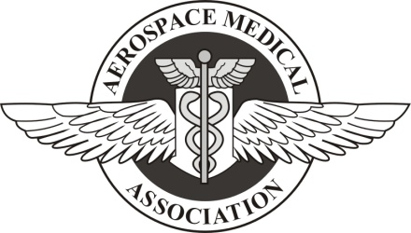
Aerospace Nursing Society

Constituent Organization of the
Aerospace Medical Association

Report to Council
May 9, 2010

Meetings –No additional meetings were held from Fall 2009

Updates –
--Panels on CCATT, Research and Equipment, Global Patient Movement as well as Aeromedical History were accepted with ANS co-chairing.
--Request for transfer to Affiliate Organization status submitted at AsMA Conference, Phoenix.

Membership – A list was collated from the ANS and AsMA lists of nurses. The secretary reached out to members whose ANS dues are out of date or who are members of AsMA but not ANS by e-mail and letters inviting them to return to the society. An e-mail went out to contact all chief nurses of aeromedical evacuation squadrons in Air Mobility Command, Air Force Reserve and the international heads of flight nursing/aeromedical evacuation. There were very few responses to any of these queries. The actual membership count is now twelve nurses/EMTs.

ANS Committee reports
-Scientific
Since AMSUS and the Scientific Program Meeting coincided, ANS will unfortunately only have minimal representation at the November meeting.
-Awards
The awards categories and requirements were included in the letters for the nursing leadership of the US and international aerospace communities but there were no submissions beyond that for Mary T. Klinker.
-Arrangements
The Aerospace Nursing Society Luncheon will be Wednesday during the lunch break. There will be no guest speaker. This will be a business meeting. A request to announce that in the opening remarks was sent to the Home Office May 2nd.

Officers – Current
President – Nora Taylor
Vice President/President Elect – Eleanor Jarrett
Secretary – Christine Cloutier
Treasurer – Eileen Hadbavny
Members at Large – Colleen Morissette & Olsa Hahn

Committees -
Education/Training –Janet Sanner
Science Program – Diane Fletcher
Awards – Nora Taylor
Bylaws – Kirk Nailling and Olsa Hahn
History and Archives – Kimberly Barber
Meeting Arrangements – Cathy DiBiase
Publicity – Cathy DiBiase
Membership – Christine Cloutier and Colleen Morissette
Nominations – Diane Fletcher

Thank you for your time.
Nora Taylor
ANS President
Work phone – (314) 923-5628
Cell - (618) 604-8034
Email – noralaska@yahoo.com
mailto:Catherine.P.Dibiase@nasa.gov

Aerospace Medical Association
320 South Henry Street
Alexandria, VA 22314-3579
Phone: 703-739-2240
Fax: 703-739-9652
www.asma.org

AEROSPACE PHYSIOLOGY SOCIETY

REPORT

April 29, 2010

ORGANIZATION NAME: Aerospace Physiology Society

BOARD OF GOVERNORS:
Joseph B. Essex, President
Thomas J. Wheaton, President Elect
Anthony Artino, Secretary
Andrew Woodrow, Treasurer
Dan Roberts, Bibliographer
Paul R. Gardetto, At-Large Member (2012)
Jim Lasswell, At-Large Member (2011)
Jim Webb, At-Large Member (2010)
Donald J. White, Immediate Past President
Lynn Wheeler, One-Year Past President

COUNCIL REPRESENTATIVE: Vince Musashe
Society Activities since last report to Council:

1. Planning for the 81st annual ASMA Scientific Meeting is complete.
2. The Society’s Education and Training Day panel session at the 81st AsMA Scientific Meeting is entitled Aerospace and Operational Physiology: Training systems and simulations to support the warfighter. It looks to be an outstanding panel presentation.
3. On Wednesday 12 May, Dr, Jan Stepanek will present the Smith Ames Memorial Lecture at the Society’s annual luncheon. The Lecture is sponsored by the David Clark Company. The theme will be novel avenues for training aircrew.
4. The Society’s social will be held on Wednesday evening, May 12th at the Arizona Diamondbacks home baseball game vs the Los Angles Dodgers. This event is being co-sponsored by the Human Factors Association. We expect a great attendance.

5. As of 29 April 09, the Society Treasurer reports a positive balance of $748.24.
6. The Society’s Awards Committee has completed the selection of three very deserving individuals for the Society’s awards. This year’s selections will be announced at the annual luncheon. An honorarium of $250 is awarded to each recipient. We wish to thank our sponsors: International ATMO (Fred Hitchcock Award), Gentex Corporation (Wylie Post Award), and Wyle Laboratories (Paul Bert Award).
7. Election of President Elect, Member-at-large and bibliographer will be conducted at this meeting and via email with winners announced no later then June 09.
8. The Partnership in Education Award, sponsored by the Society, will be awarded this year to Ms. Dawn Gorosics, a Life Science Teacher at Willow Canyon High School. Ms. Gorosics will be invited to attend our Luncheon to receive her award.
9. The Society’s top priority this past year was improving the use of the society website for enhanced information distribution and management. We made significant progress and will be continuing to migrate to a web-based system.

10. A second priority for the Society was locating a permanent home for its archives. This effort was undertaken to ensure preservation of the rich history and significant contributions of the society to the Aeromedical Community and Aerospace Medical Association. As a result of the efforts of Dr’s Webb and Rayman, arrangements were made to consolidate our record and store them at the ASMA home Office.
Joseph B. Essex
President, Aerospace Physiology Society (2009-10)

REPORT TO COUNCIL
AEROSPACE MEDICAL ASSOCIATION
AIRLINE MEDICAL DIRECTORS ASSOCIATION
09 MAY 2010

OFFICERS:
President Mike Waring
President Elect Ed Bekeris
Secretary Ralph Fennel
Treasurer Wayne Kendall
Council Representative Gordon Landsman

MEMBERSHIP:
Active 84
Associate 37
Emeritus 37
Honorary 6

ACTIVITIES:
Coordinate complimentary AMDA & CAMA Scientific Programs to begin at
this AsMA Meeting.
AMDA Scientific Program, Sat. 09 May 2010
CAMA Sun. 09 May 2010
Business Meeting, Sat. 08May 2010
Ed Bekeris will be installed as President

PROPOSALS:
Status of Airline Medical Departments as Workshop during 2010 Annual
Scientific Meeting under Chairmanship of Yvette DeBois

AEROSPACE MEDICAL ASSOCIATION
320 South Henry Street
Alexandria, VA 22314
www.asma.org

American Society of Aerospace Medicine Specialists Letter to the AsMA Council 2010

May 9, 2010

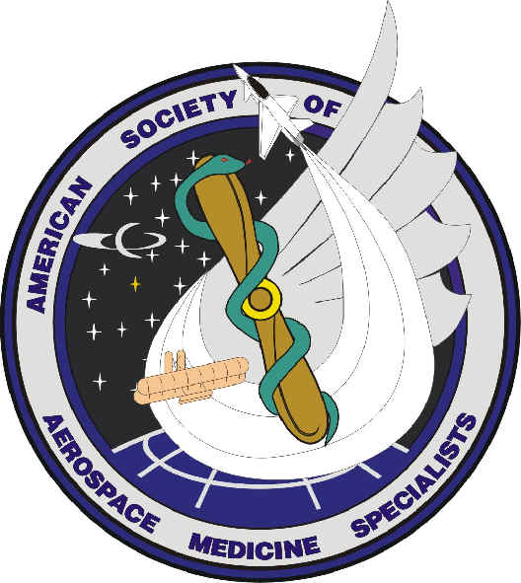

The impacts of military deployments and distance continue to take a toll on the availability of several society members throughout the year. Continuity management, meeting participation, and membership communication have significantly improved this year. Several virtual meetings via Email correspondence took place over the course of the year to coordinate ASAMS business and advocate for ASAMS members.

ASAMS Officers for the 2009-10 year;
Pres – Dr Robert Johnson
Pres Elect/VP – Dr Sue Northrup
Treasurer – 2yr term – Dr Jeanine Czech
Secretary – extended by 1 year – Dr Ortega
BOG member – Dr. Joe McKeon

This year ASAMS focused on three major areas, Aerospace Medicine Education, service to members, and outreach to Aerospace Medicine Residents. The major activities included the cleanup of our member email database, the coordination of an ASAMS comment to the ACGME Preventive Medicine Residency Review Committee, formation of a committee to work on developing an ethical guidelines for Aerospace Medicine Specialists, continued work on development and review of Clinical Practice Guidelines, continued work on maintenance of certification part 4 (MOC 4) programs for our members and other preventive medicine specialists, and sponsorship of the RAM Bowl at the 2010 AsMA Annual Scientific Meeting.

We continue to maintain a positive financial picture with an account balance of nearly $9000.00. The membership approved the design and purchase of ASAMS coins which were purchased in early April 2010 and should be available at the meeting in Phoenix.

An ASAMS BOG meeting is planned for Tuesday May 11, 2010 and the Annual ASAMS General Membership meeting is scheduled for Thursday morning May 13, 2010. The agenda includes reports from all the standing committees, discussions regarding MOC 4, progress on development of ethical guidelines, consideration of a lunch meeting or reception at the ASMA 2011 Meeting, and an election for Vice President/ President Elect and two BOG members.

Respectfully submitted,

Dr Robert Johnson, MD, MPH
President, 2009-10

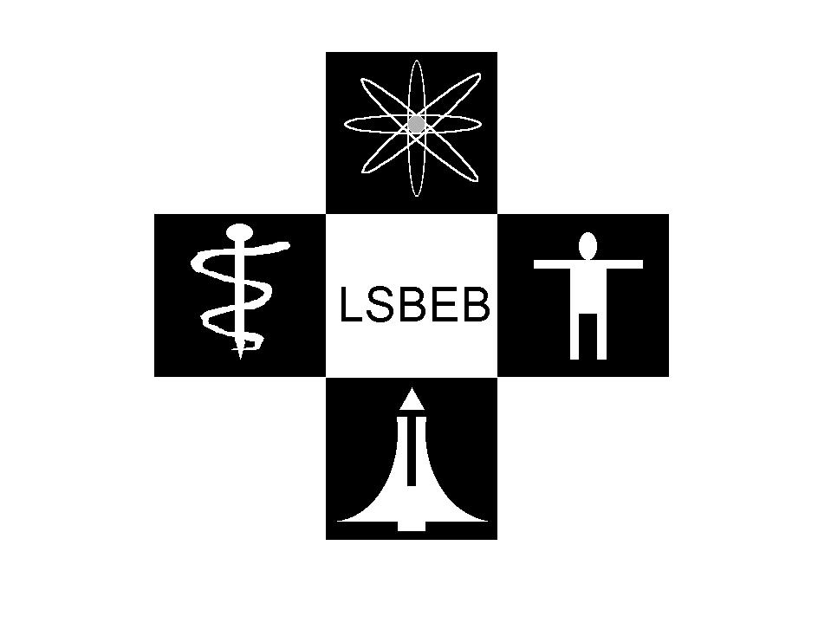
LIFE SCIENCES & BIOMEDICAL ENGINEERING BRANCH
a constituent organization of the

Aerospace Medical Association

LSBEB REPORT TO COUNCIL
9 May 2010

The following are the Life Sciences & Biomedical Engineering Branch activities since last report to AsMA Council:

Board of Governors

President – Deborah White (5/09 –5/10)
President Elect – Tom Morgan (5/09 – 5/10)
Secretary/Treasurer – Andy McKinley (5/08 – 5/10)
Historian – Bill Fraser (5/07 – 5/11)
Member-at-Large – Hans Pongratz (5/08 – 5/10)
Member-at-Large – Valerie Martindale (5/09 – 5/11)
Immed. Past President – Bill Ercoline (5/08 – 5/09)

Chairs and Appointments

Program Committee Chair - Arvind Chaturvedi
Membership Committee Chair - Brian Self
Long-Range Planning Chair - Vacant
Awards Committee Chair - Barry Shender
Nominating Committee Chair – Bill Ercoline
LSBEB Rep. to AsMA Council - Lloyd Tripp
LSBEB Rep. to AsMA Nom. Com. - Robert Shaffstall
LSBEB Rep. to AsMA Award Com. – Bill AlberyChairs and Appointments

New officers (President Elect, Secretary/Treasurer, and Member-at-Large) will be announced during the LSBEB annual meeting to be held at 4:00 p.m. (1600) on Monday, 10 May, in the Laveen A Conference Room at the Sheraton Phoenix Downtown Hotel. Also at this meeting Mr. Tom Morgan will take over as LSBEB President.

Membership

One of LSBEB’s top priorities this past year was updating our membership roster to enhance information distribution and facilitate membership status. We also established a PayPal account to encourage prompt and easy payments in order to improve membership numbers. Planning and development are also underway to establish an LSBEB website through the AsMA portal and we will incorporate a membership link to our new website. We expect to submit the updated list of members after the AsMA meeting.

Treasury

The current LSBEB treasury holds approximately USD $1848.90.

LSBEB recently established our own Employer Identification Number from the IRS and will be submitting a Form 990-N (e-Postcard).

LSBEB Awards

Four 2010 LSBEB Awards will be presented at the annual LSBEB business meeting, Monday, 10 May 2010. Each of the four awards is commercially sponsored and consists of a plaque as well as a cash honorarium.

- Professional Excellence Award
- A. Howard Hasbrook Award
- Research and Development Innovation Award
- Ross McFarland Student Award

Scientific Panel

Once again LSBEB is co-sponsoring a Panel with the AsMA Science and Technology Committee on Monday, 10 May at 1030 in the Alhambra Room. The title is EFFECTS OF GENDER ON DYNAMIC LOADING RESPONSE. The co-chairs are Barry S Shender and Glenn Paskoff. The agenda is as follows:

- Effects Of Gender On Dynamic Loading Response (Shender)
- Are Women Just Small Men? The Effect Of Gender On Human Response To Impact (Bass)
- Gender Differences In The Geometric And Inertial Properties Of The Adult Human Head (Damon)
- Role Of Gender-Dependent Neck Muscle Anatomy On Head-Neck Stability (Stemper)
- Gender Bias In Lumbar Spine Spondylolisthesis: A Possible Biomechanical Etiology (Stemper)
- Gender-Based Differences In Kinematic Response To The Catapult Phase Of Ejection (Shender)
- Determining The Effects Of Gender On The Probability Of Injury During Ejection Using A Parametric, Probabilistic, Finite Element Cervical Spine Model (Francis)

LSBEB Planned Goals

- Increase LSBEB membership
- Increase LSBEB role/contribution – in general and in AsMA activities.
- Launch new LSBEB website
- Fill vacancies.
- Increase corporate sponsors and award recipient gifts.

Respectfully submitted,
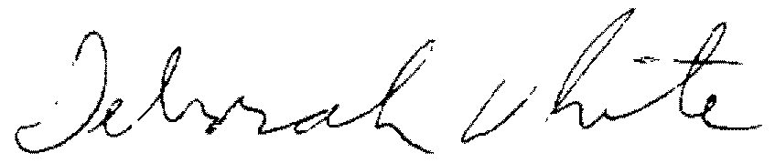
Deborah White, LSBEB President

Report from the Society of USAF Flight Surgeons (SoUSAFFS)
Aerospace Medical Association Council Meeting
May 9, 2010
Sheraton Downtown Phoenix Hotel, Phoenix, AZ

Report to AsMA Council from SoUSAFFS

SoUSAFFS is celebrating our 50th Anniversary this year. We will display a banner at the Annual Scientific Meeting and will have commemorative coins for sale. Our most recent issue of FlightLines was centered around this historical milestone and featured interviews with founding members.
In recognition of the increasing relevance of remotely piloted vehicles (RPAs), we have invited as our guest speaker for our Luncheon the 432d Air Expeditionary Wing Commander, Col Pete “Gunz” Gersten.
Our incoming President is Col Tim Jex. His current e-mail is timothy.jex@pentagon.af.mil but it will change this summer. If you have any difficulty reaching him, please don’t hesitate to ask for my help.
v/r
Peggy Matarese
Margaret B Matarese
Col, USAF, MC, CFS
Air Education and Training Command
Command Surgeon
Comm 210 652-9501
DSN 487-9501
FAX -6615
BB 210 601-1512

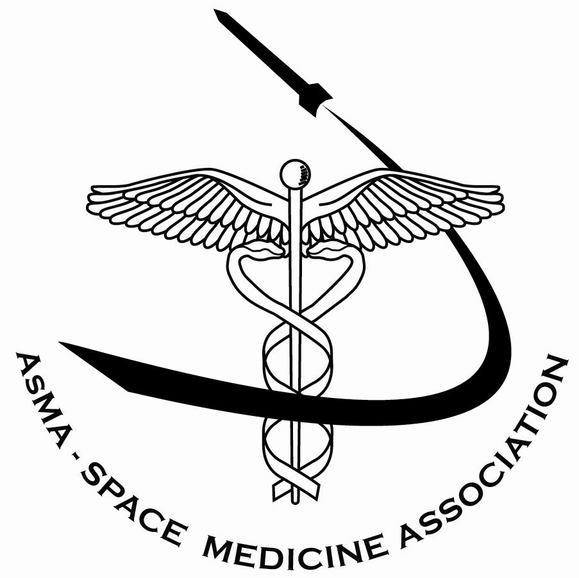 | Space Medicine Association  (SMA)  a constituent organization of the  Aerospace Medical Association (AsMA)
Report to AsMA Council
May 9, 2010

Officers:
President : Patrick McGinnis (2009-2010)
President Elect: Jan Stepanek (2009-2010)
Secretary: Karen Mathes (2008-2010)
Treasurer : Mike Chandler (2009-2011
Members at Large:
- Shannan Moynihan and Serena Aunon (through 2012);
- Mark Edwards and Sam Strauss (through 2011);
- J.D. Polk and Scott Parazynski (through 2010)

Chairs and Appointments:
Immediate Past Presidents: Genie Bopp and Mark Campbell
Awards committee: Jeff Myers, Smith Johnston, Mark Campbell, Mike Chandler
Policy Committee: Phil Scarpa, Jim Webb
Communications Committee- Vernon McDonald
Finance Committee: John Charles, Genie Bopp, Pat McGinnis, Dwight Holland, Jeff Myers and Alex Garbino
Multi-national Committee: Volker Damann
SMA Website Committee: Mark Campbell, Jan Stepanek
Corporate Sponsorship Committee: Pat McGinnis, Dwight Holland, Karen Mathes
Historian and keeper of the gavel: Mark Campbell

AsMA Council Representatives- Phil Scarpa, Jim Webb, Mark Campbell, Joe Dervay
- Program Committee: Phil Scarpa, Densie Baisden
- Nominations: Denise Baisden
- Web Site Development: Jan Stepanek

Membership:
The SMA currently has these members; 139 regular, 5 student,11 emeritus, 21 lifetime, and 2 honorary. (Total of 178).

Treasury:
The current balance is $36,255.61. Outstanding Deposits (dues and donations): 1350.00
SMA is grateful for the generous donations to our scholarship and award fund from Bob Ellis of Wyle Integrated Science and Engineering and personal contributions from Jeffrey Davis, Jeff Myers and Mark Campbell.

SMA sponsored Scientific Panels planned for 2010:
- Human Systems Risk Management: Judy Robinson
- Analogs for Exploration: Advancing Science and Operations: Lauren Levitan
- Co-sponsored Panel : Sensorimotor Challenges of Space Exploration Missions: Charles Oman

Space Medicine Association News in ASEM:
- US Space Medicine Operations - Parazynski, Gast and Scheuring; June 2009
- Humans in Air and Space; Looking Beyond 2020 - Young; July 2009
- Space Medicine Annual Meeting Report - Bopp; August 2009
- Doctors Set Record in Space, Maybe - McGinnis; October 2009
- Aerospace Medicine at the Mayo Clinic- Stepanek; November 2009
- Update on Health Informatics - McGinnis and Schuering; April 2010

Upcoming articles:
- ESA Medical Operations- Volker Damann
- Commercial Spaceflight passenger screening- Jennings and Vanderploeg
- Report on the Commercial Suborbital Science Workshop- McDonald
- SMA Response to Space Studies Board AG White Paper - McGinnis and Parazynski

Special Mention of a New Contribution:

- Dr. Mark Campbell has been the founder and monthly editor of a new feature: “Classics in Space Medicine”

Awards and Scholarships:
- Hubertus Strughold Award- given each year to a member of the SMA who has shown exceptional leadership or has contributed significantly to the field of Space medicine
- Jeffrey Myers Young Investigator Award- given each year to an author of a paper who presents at the AsMA scientific meeting for the first time. a full paper must be prepared which is reviewed and voted upon by the SMA Award Committee.
- Space Medicine Association Scholarship sponsored by Jeffrey R. Davis- a $500 scholarship to be awarded each year to a student in pursuit of a degree (internship or residency) related to Space Medicine
- Space Medicine Association Journal Award- award to be given to the best article published in the ASEM by a SMA member
- Presidents Award- given yearly at the discretion of the SMA President for lifetime achievement in the area of space medicine.
- Wyle Scholarship: A new $500 scholarship reflecting longstanding support of Wyle and established in honor of Bob Ellis. The purpose of the SMA Wyle Scholarship is to encourage students, who have demonstrated academic achievement and have shown an interest in Space Biology and Space Medical Operations (e.g., biomedical engineering, space flight physiology, human factors research, nursing, psychology, safety, life sciences, etc.) to further pursue a career in Space Medicine.

Other activities:
- Development of a Procedures Manual which describes the duties of all of the officers and committee chairs has been completed
- The Commercial SpaceFlight Working Group met in November 2009 and will have another meeting on May 9, 2010.
- Volker Damann now leads the (re-named) Multi-National Committee, and its website is at: http://space-book.eu .
- Input and refinements were made to the SMA By-Laws.
- Mark Campbell coordinated inputs to the AsMA Foundation Fund as related to the inclusion of SMA Fund. The organization is considering the inclusion of close to $30,000.00 into the Foundation for investment management, if a revised agreement can be negotiated with the AsMA Foundation.
- Jan Stepanek taking leadership within the SMA for the Oral Histories Project.
- SMA submitted its own response the the Decadal Paper for the Space Studies Board, authored by Pat McGinnis and Scott Parazynski.
- Continued development of the SMA web site, which received 1500 hits over the last 12 months, 850 which were unique individuals. We are developing a Space Medicine/ Space Medicine Association history timeline on the website which will have extensive links to photos, published papers, documents, and videos
- In 2009, the Executive Director mandated the Space Medicine Association to establish a Commercial Space Flight Working Group which is currently working on a position paper concerning crew member issues on sub-orbital space flights. This is a comprehensive document that covers the history of previous animal and human sub-orbital space flight experience, the history of previous studies on the medical issues of commercial space flight, the medico-legal issues of human comercial space flight, and finally a summary of the various medical issues themselves. It is not focused on recommendations or on medical certification requirements as did the previous AsMA position paper, "Medical Certification for Pilots of Commercial Suborbital Space Flights" from 2009, but is an attempt to be more informative in nature. It is expected that this position paper will be completed soon and it will then be forwarded to the AsMA Council for approval.

ACPM
American College of
Preventive Medicine

Semi-Annual Report to the Council
of the
Aerospace Medical Association

- ACPM BOARD APPROVES RESPONSE TO PROPOSED CHANGES IN PREVENTIVE MEDICINE RESIDENCY TRAINING REQUIREMENTS
- ACPM SUBMITS CONGRESSIONAL TESTIMONY ON FY 2011 HEALTH APPROPRIATIONS
- HOUSE AND SENATE MEMBERS EXPRESS SUPPORT FOR PREVENTIVE MEDICINE RESIDENCY TRAINING PROGRAMS

ACPM BOARD APPROVES RESPONSE TO PROPOSED CHANGES IN PREVENTIVE MEDICINE
RESIDENCY TRAINING REQUIREMENTS
At the recent Preventive Medicine 2010 conference, the ACPM Board of Regents approved an official
response to the Accreditation Council for Graduate Medical Education (ACGME) Preventive Medicine
Residency Review Committee's (RRC) proposed revisions to preventive medicine residency training
requirements. The response, which was carefully crafted by the ACPM Graduate Medical Education
Committee, urged the RRC to proceed cautiously and not change the core public health competencies of
preventive medicine residency training programs.
In its review of the requirements, the RRC closely examined the strength of clinical training and the relevance of academic coursework to physician post graduate training in Preventive Medicine. In an accompanying impact statement, the RRC proposed several major changes to specialty training, including a minimum of 24 months of training in the Preventive Medicine Residency, the definition of minimum, fundamental clinical skill competencies, and progressive educational experiences within a patient care environment and in ambulatory settings. While the requirements also include weekly didactic sessions in the core public health sciences (e.g., biostatistics, epidemiology, administration, and behavioral health), they no longer require the acquisition of a master's degree in Public Health.
To view a copy of the ACPM letter and supporting documentation please visit, http://www.acpm.org/RRC/RRC-documents.htm.
ACPM SUBMITS CONGRESSIONAL TESTIMONY ON FY 2011 HEALTH APPROPRIATIONS
ACPM submitted testimony to the respective House and Senate Appropriation Subcommittees on Labor, Health and Human Services, and Education urging that $5 million be appropriated to the Health Resources and Services Administration (HRSA) in FY 2011 for preventive medicine residency training programs. The goal is to secure sufficient funding by FY 2012 to, at a minimum, maintain the $7 million investment in preventive medicine residency training programs realized through the American Recovery and Reinvestment Act (ARRA). HRSA funding for preventive medicine in FY 2010 was $2.3 million.
To view a copy of the testimony please visit, http://www.acpm.org/CongressTestimonyFY11 HRSABudget.pdf.
HOUSE AND SENATE MEMBERS EXPRESS SUPPORT FOR PREVENTIVE MEDICINE RESIDENCY TRAINING PROGRAMS
Sen. Tom Udall (D-NM) and Rep. Gene Green (D-TX) circulated a "Dear Colieague" lelter in their respective chambers urging support for increased FY 2011 funding for all preventive medicine residency training programs. "Dear Colleague" letters offer members of Congress the opportunity to sign-on to a letter and show their support for a particular issue or cause.
The preventive medicine "Dear Colleague" letters were delivered to their respective Appropriations Committee leadership requesting a FY 2011 allocation of $5 million for preventive medicine residency training programs. Combined with the $9 million recently made available through the Health Resources and Services Administration (HRSA). this funding would increase federal support for preventive medicine residency training programs in 2010 to $14 million. The start of the FY 2011 fiscal year is October 1.
To view the House and Senate "Dear Colleague" letters please visit http://www.acom.org/LtrSenateApprop-FY11 .pdf and http://www.acpm.org/Ltr-HouseApprop-FY1 1.pdf.
Respectfully submitted,

Christopher R. ,Armstrong, D, MPH, FACPM Aerospace Medicine Regent
2

AMSRO Report – May 2010 Council Meeting
Alex Garbino, President

AMSRO has been working to reach out to all of AsMA’s student and resident members and get them on board with our organization. We are distributing our newsletter, Orbiter¸ to members and also among members' institutions.

President: Alex Garbino
Vice President: Tovy Kamine
Secretary: Natacha Chough
Treasurer/Membership Coordinator: Derek Nusbaum
Parliamentarian: Greg Shaskan
Chief Editor: Charles Mathers
Website Coordinator: Jennifer Law

I. GOALS

Our goal is to provide a strong organization with 5 key roles:

Student Advocacy – AMSRO is the voice of students in AsMA, representing them in the Executive Council. We will also focus on reaching out to students outside the aerospace medicine community, to increase awareness and interest in the field. We will do this via promoting electives and providing source material and templates that can be used to create modular talks to be given by members at their home institutions.

Research and Scholarship – AMSRO offers an annual $1000 travel scholarship, and a Scientific Paper award to the best paper by an AMSRO member at the Annual Meeting.

Professional Development – Providing a peer group of fellow students is an important aspect of career development, but we also focus on fostering interactions with existing members. The mentorship program is the key to enable students a rapid understanding and integration into how aerospace medicine happens.

Education – We do not want to limit AMSRO’s outreach to medical students and residents. Our goal is to inform the community at large about what aerospace medicine is and what it does.

Leadership – We want AMSRO to also be an opportunity for students to develop their leadership skills. Members can serve not only in AMSRO’s executive committee, but also in AsMA’s committees as representatives.

II. PROGRESS REPORT

- The $1000 Travel Award was disbursed, and over the last year received increased interest in additional scholarships to fund travel. We are listing all available opportunities on our website, and we also rely on our mailing list to communicate new opportunities to the members. We encourage other constituent organizations to offer student scholarships.

- Our website, www.amsro.org, is up and running. We have the newsletter, scholarship announcements, and other content already posted. We hope that with the influx of new members we can get member-driven content to add to the site.

- We have students forming chapter at McGill University and in Philadelphia. There is also a new chapter starting at Embry-Riddle Aeronautical University; they will serve not only to recruit new members from the local communities but also serve as an example for other students to start chapters at their institutions.

- We are building a significant list of student rotations, research opportunities, and courses. We encourage AsMA members to refer students in their institutions to our website.

- We are also reinstating our Scientific Award. It is an annual award that recognizes outstanding scientific achievement by one of AMSRO members.
- We are also starting a AMSRO Mentor Dinner this year. It provides a great opportunity for students and residents to network with aerospace medicine professionals. We already have many students signing up – however, we are also looking for mentors to volunteer their time. Please contact me if you would like to participate.

Respectfully Submitted,

Alex Garbino
President, AMSRO
garbino@bcm.edu

Aerospace Medical Association
320 South Henry Street
Alexandria, VA 22314-3579
Phone: 703-739-2240
Fax: 703-739-9652
www.asma.org

REPORT TO COUNCIL

May 9, 2010

Name: Corporate and Sustaining Membership Affiliate

President: Marian B. Sides, Ph.D., FAsMA
Col USAFR NC (ret)

Membership : The Affiliate has 47 active members

Affiliate Members: Corporate Members are listed monthly in the Journal and are
posted on the AsMA web site

Affiliate Mission Statement

To enhance and promote the goals of the Aerospace Medical Association, by attainment and retention of support from the aerospace medicine, allied health, and aviation operations community, through corporate membership; to enhance the professional and business benefits to corporate and sustaining members.

Affiliate Activities

OFFICER ELECTIONS. Candidates for the offices of the President, Secretary and Historian, emerging from the corporate membership, are slated for election at the annual business meeting . This event marks the official separation of the Affiliate from the C&S Committee and is a bold statement of accountability and ownership of the corporate entity within AsMA. .

CORPORATE FORUM. The second annual Corporate Forum will be presented on Sunday, May 9th. All current corporate members received personal invitations through the home office for this event. This program features a presentation of AsMA objectives, outreach and advocacy activities and a historical overview of the Corporate Affiliate. Highlights of corporate member strategies for optimization of their affiliation with AsMA and opportunities for corporate involvement will be presented. Needs assessments will be conducted with corporate participants following the Forum.

ANNUAL BUSINESS MEETING. The Corporate Affiliate will host it’s first annual luncheon and business meeting at noon on Monday, May 10th. The luncheon will feature a panel presentation, “Challenges Facing US Internal Airline Medical Departments.” Interested members are welcome to attend the panel presentation, which will commence following the business meeting.

EXHIBITOR PROGRAM. The Exhibitor Greeting and Solicitation Program will be conducted on site in Phoenix, to individually greet exhibitors, to thank them for choosing to exhibit with us and to solicit new corporate members from the existing exhibitor base. Many exhibitors are not corporate members. An exhibitor satisfaction assessment survey will be conducted to determine the perceived value and usefulness of the exhibit experience, satisfaction with the exhibit area, positioning, setup, and business generated during the meeting. A formal solicitation packet will be sent to those exhibitors who express interest in becoming corporate members.

SIXTH ANNUAL SPEAKERS BUREAU EVENT. The C&S Affiliate will sponsor the Sixth Annual Speakers Bureau event on Tuesday,May 11th. Jan Stepanek,M.D. Medical Director, Aerospace Medicine, Mayo Clinic will present, Commemorating the 40th Anniversary of the Lunar Landing, Space Flight and Aerospace Medicine: “Aerospace Medicine at Mayo Clinic.”

CORPORATE AFFILIATE FINANCE. The C&S Finance Committee, headed by Dan Callan, MD is exploring avenues for financial support for operational expenses .Corporate membership generates nearly $20,000 annually to the association. That revenue will continue to increase and so will the expenses. Currently, no provision exists for handling expenses associated with program development, membership solicitation and other miscellaneous expenses. Operating expenses are paid for personally by committee members.

C&S COURIER. The May 2008 issue of the C&S Courier , the official newsletter of the C&S Affiliate , is published and remains timely in it’s presentation of current events. This newsletter, designed and edited by Yvette DeBois,MD MPH is a dynamic communication tool which features news about corporate members and is written in part by our corporate members. The newsletter is a splendid way to stay current with news and activities of corporate members.

HISTORY INITIATIVE. This initiative is an effort to capture and document corporate involvement in the Association over time. A working group has been formed and is currently examining records at the AsMA home office in Alexandria as well as retrieving information electronically. A data base set up will be established for storage of historical information of significance and for future accomplishments.

PHILANTHROPY. A philanthropic initiative is underway in the C&S Affiliate. This subcommittee will capture activities of our current corporate members and seek to identify funding sources from philanthropists external to AsMA who are looking for opportunities for planned giving.

WEB SITE. The C&S web site content is being developed for the AsMA web site to facilitate communication with corporate members and networking among members.. It is being designed as an interactive workplace and will archive all programs and activities sponsored by the Affiliate.

CORPORATE SURVEY. A corporate survey was conducted in April, 2010. Networking was ranked #1 in perceived value of corporate membership by 23 survey participants. A complete analysis of survey results is available from the C&S Membership Committee.

GOALS . Our continued goal is to increase membership in the Affiliate and to retain current members. It is our mission to enhance the professional and business benefits to corporate and sustaining members while promoting the goals of the association. Our membership committee continues to work with our corporate representatives to keep abreast of current issues, interests and concerns. We thank all committee members , especially Yvette DeBios MD MPH for their support and for nourishing our growth over the years. We thank all corporate members for their unifying efforts, initiatives and inspiration, which bring us to this historical moment.

A special thank you is extended to members of the home office for their ongoing support in these corporate membership efforts.

Respectfully submitted,

Marian B. Sides, Ph.D., FAsMA
Col USAFR NC (RET)
President, C&S Affiliate

Brussels, 19 April 2010

ESAM, the European Society for Aerospace Medicine

ESAM's objectives under its Statutes are to be an independent pan-European forum and to work for the safety and health of all persons involved in aviation and space operations, including passengers. Our advice and decisions are built on knowledge, evidence and open discussions within the Society.
We therefore encourage information exchange and dialogue between the member associations on subjects such as harmonisation of education in aerospace medicine.
To ensure that European aero-medical professionals speak with one voice, we have developed relations with EASA, EUROCONTROL and other appropriate regulatory and scientific organisations in Europe and worldwide.
Since our creation in 2006, ESAM has grown substantially. We are not, however, an association based on individual subscriptions but an umbrella association made up of existing national and international associations, and now represent 44 societies and about 4,000 professionals in the field of aviation.
We are not a trade union defending the individual rights of AMEs but a scientific organisation defending the place of aerospace medicine in the global safety of the skies.
The Society is governed by an Executive Committee of seven members, and has a scientific Advisory Board with one member from each association. Our Statutes also make provision for two auditors, a Nomination Committee (to prepare for elections, the next of which are scheduled to be held at the General Assembly in Athens on 13 November 2010) and a Conference Committee for the two-yearly ECAM (European Conference of Aerospace Medicine). We have regular members (the European national aero-medical associations) and associate members (other linked national or international organisations).
The ESAM Statutes were officially registered in Cologne in March 2008, and we launched a (www.esam.aero) as our main information tool.
At important international congresses such as the AsMA scientific meetings and the ICASM congresses, ESAM holds meetings or organises panels or presentations. In accordance with our Statutes, we will be holding our second congress in Athens with the Hellenic Society from 10 to 13 November 2010, at which AsMA will also be represented.
The Advisory Board gives independent scientific advice to the Executive Committee, and is chaired by a three-member Board. It sets up multinational groups of expert aerospace medicine professionals (in areas such as space medicine, human factors and ATC, and with related clinical specialists such as aviation cardiologists, ophthalmologists, ENT specialists, internal medicine specialists, neurologists, psychiatrists, etc.) in order to build on common position papers and to hold meetings. The first of these took place in Wiesbaden in August 2008, and the second is scheduled for July 2010 to discuss EASA's Comment Response Document in connection with its Opinion on flight crew licensing to be submitted to the EU Commission.
ESAM has also representatives in every EASA ESSI (European Strategic Safety Initiative) group: EHEST for helicopters, EGAST for general aviation and ECAST for commercial aviation. These are preparing possible safety topics for regulation by EASA. As from 2010, we have also the representative for European aviation medicine on the SSCC, one the two steering committees of the EASA Rulemaking Directorate.
We ware invited to take part in the group reviewing the NPA proposal on flight crew certification, which included the very controversial LAPL (Light Aircraft Pilot Licence), together with representatives of European air sports, the ECA, the association of disabled pilots and the CMOs of Sweden , France and the UK. Following lengthy debates (there were 2400 medical comments), a heavily modified version of the proposal for the LAPL (concerning the validity period, medical questionnaire, medical criteria and the conditions for the use of a GMP) will be published in the EASA CRD before the end of May, which leaves us until the end of July (two months) to respond to this document. The EU Commission may alternatively accept a system with two levels of medical certification, i.e. lower medical standards for gliders, balloons and aircraft up to 1 tonne carrying only one or no passengers, and a higher standard (possibly ICAO Class 2) for heavier aircraft. Discussions are still continuing at the time of writing of this document.
The criteria for Class 1 pilots will not really change and EASA Class 2 will be in line with ICAO Class 2 criteria.
The discussions regarding the use of a GMP are the result of the differing roles of GPs in the various EU health systems and their access to the full medical files of applicants (national health system versus open-choice health systems).
At ESAM, we feel that it would be dangerous to apply the use of GMPs in countries with open-choice health systems (most continental EU countries) where G(M)Ps do not have the same privileges and access to medical data as in national health systems.
The ESAM working group on harmonisation of aerospace medicine training in Europe has published a syllabus with the input of 18 associations, taking into account actual arrangements, costs and content, with the aim of modernising such training. This proposal was based on the former JAA syllabus (60 hours of basic and 60 hours of advanced training) and has been sent to EASA. It may have to be integrated with the competency-based training now developed by ICAO. We have to take into account the fact that the responsibilities of AMEs and AeMCs may increase in the future, and appropriate training is thus an important safety matter.

Dr Roland Vermeiren
President of ESAM

Report from the German Society of Aerospace Medicine (DGLRM)
Aerospace Medical Association Council Meeting
May 9, 2010
Sheraton Downtown Phoenix Hotel, Phoenix, AZ

Since the last annual Meeting of AsMA in Los Angeles our DGLRM was very strongly involved -in the development of the new EASA (European Aviaton Safty Agency) Regulation in replacing the JAR-FCL 3 Regulations.
There were a lots of work to do, especially concerning a new license for private pilots, the so-called LPL or LAPL(leisure pilot license or light aircraft pilot license) -we have had to fight for AME of age 68 or older, because legal restrictions have forced them to stop their AME -work.
-the German Air Force Institute of Aviation Medicine(GAF/IAM)is an important part of our DGLRM. There for it was very remarkable that the Council of Science and Humanities of the German Government summarized the evaluation process of the GAFIAM in a press release:

"The German Air Force Institute of Aviation Medicine makes an indispensable contribution toward the safety of military aviation. Its research that is highly application-oriented and tailored to the requirements of our armed forces, is of good and very good quality. Its science-based services are valued as very good, some of them even as excellent."

-furthermore the Institute has celebrated in 2009 his 50-th Anniversary in a great ceremonial act.
-the annual scientific meeting of our DGLRM took place in the 18th and 19th of September in Fürstenfeldbruck.
Challenging and interesting topics were important for the great success.
This year our meeting are going to take place in August in Wiesbaden together with a FAA-Seminar.
-an important issue for our society is the development for the future challenges. We have to be attractive, we have to point out why we are the most competent partner for the whole aerospace community concerning scientific research as well as practical work in the day-to-day business. Therefore we installed a working group with emphasized specialists to create a new policy.
-seven working groups are working in an ongoing process on different scientific topics.
-our society is well engaged in the activities of the European Society of Aerospace Medicine (ESAM) and Dr. Hans Pongratz (also member of our board) was elected as Representative to the AsMA.
-Col Dr. Kimmich, President and former Commander of GAF/IAM, retired to the end of February this year.
-for more information we encourage you to contact our homepage www.dglrm.de

Dr. Klaus Kimmich
President DGLRM

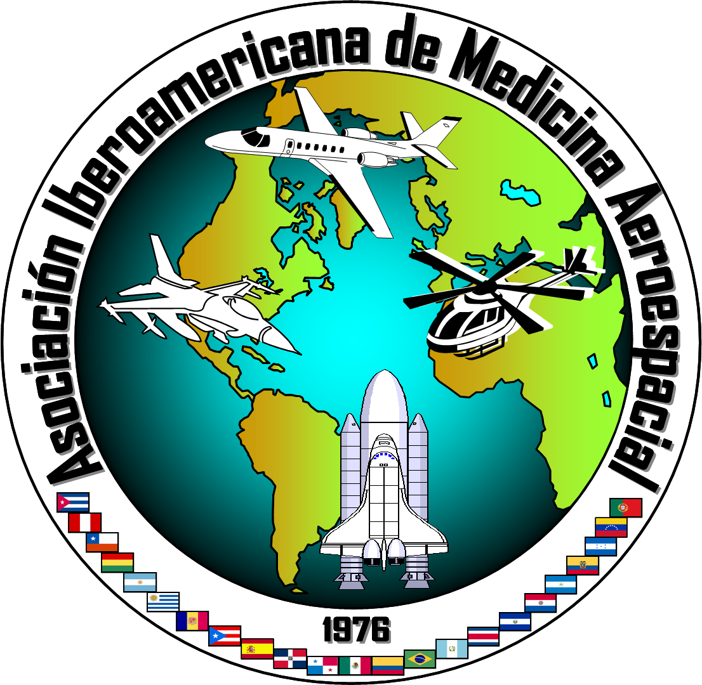

REPORT TO COUNCIL
13 April 2010

Name of Organization (Affiliate)

Iberoamerican Association of Aerospace Medicine
Asociación Iberoamericana de Medicina Aeroespacial (AIMA)

Website

http://sites.google.com/site/aima1976org/home/

President (5/2009 – 5/2011)

EDUARD RICAURTE M.D., M.S.
Civil Aerospace Medical Institute, AAM-630
P.O. Box 25082
Oklahoma City, Oklahoma 73125
405-954-2099
eduard.ctr.ricaurte@faa.gov

Vice-President 1 - President Elect (5/2009 – 5/2011)

ESTRELLA M. FORSTER Ph.D.
1331 Bittercreek Terrace
Mustang, OK 73064
(405) 954-6131
(405) 954-0130 fax
Estrella.Forster@faa.gov

Vice-President 2 (5/2009 – 5/2011)

VICTOR SALAMANCA, M.D., Col (USAF, ret.)
3610 Tupelo Place
Alexandria, VA 22304-1845 USA
(703) 340-5888
VicSalamanca@aol.com

Secretary (5/2009 – 5/2011)

VANIA MELHADO, M.D., Ph.D.
Porto Alegre, Brasil
Vania.Melhado@frbsaude.com.br

Immediate Past President

VICTOR M. RICO JAIME M.D., MGen (MAF)
Av. Industria Militar No. 1088
Lomas de San Isidro C.P. 53960
Naucalpan Mexico 553910 Naucalpan, México
+52 (55) 5294-0084
gralvictorrico@gmail.com

Other Officers

Treasurer Dr. Carlos Staff Cesu42@hotmail.com
Historian/Curator Dr. Luis Amezcua Amezcua@prodigy.net.mx
Representative to Council AIMA President Eduard.ctr.Ricaurte@faa.gov
Representative to Council (alt.) Dr. Estrella Forster Estrella.Forster@faa.gov

Key Activities at AsMA 2010

Scientific panel, held in the spanish language (sponsorship and participation)
Luncheon
Business Meeting

Respectfully submitted,



Estrella Forster, Ph.D.
Rep. to Council (alt.), AIMA



REPORT TO COUNCIL
13 April 2010

Name of Organization (Affiliate)

International Association of Aerospace Dentistry

Website

None at this time

President

LEON DYCHTER, D.D.S.
Chula Vista, CA
619-691-9009
LDychter@hotmail.com

Vice-President

RAMON DOMINGUEZ MOMPELL, M.D., M.S., D.D.S., M.S.
Madrid, Spain
0-11-34-91-433-4519
rdominguez@iberia.es

Secretary
ESTRELLA FORSTER Ph.D.
Oklahoma City, OK
Estrella.Forster@faa.gov

Other Officers

Treasurer Juliet Murphy DDS Juliet.dentalsolutions@gmail.com
Member-at-Large JL Domínguez-M DDS Mompell83@hotmail.com

Key Activities at AsMA 2010

Scientific contribution (aerospace dentistry presentations)
Business Meeting

Respectfully submitted,

Estrella Forster, Ph.D.
Rep. to Council (alt.), IAAD
Aerospace Medical Association Annual Report
February 5, 2010

The Aerospace Medical Association Foundation is a 501(c)(3) corporation founded in 2006 to support scientific and educational purposes including the advancement of knowledge in aerospace medicine, research, and educational programs. The Foundation completed an excellent year in 2009. There were a total of 29 donors to the Foundation, including many who participated for the first time. Fiscal year 2009 contributions to the Foundation totaled $11.549.54, and the Foundation’s total holdings are $43,830.16. Endowment gifts to the Foundation totaled $3, 884.54 in 2009, and endowed grant funds currently total $13,307.94. The Foundation awarded $2,000 in grants and scholarships to AsMA members during the fiscal year. This is the first year that the Foundation has been able to offer grants, and we are gratified that the commitment and generosity of AsMA members have allowed us to make this important step.

2009 was a volatile year for world markets, and this affected employment, household income, confidence, and the aviation and space industries. In spite of this problem, the Foundation had the most individual donors in its history and the endowment grew. We applaud the commitment to education and aerospace medicine of those who contributed this year. We are truly grateful for your generosity. Luckily, the Foundation delayed entering investment markets until August and experienced solid growth for our Pooled Investment Fund (PIF) that continued through the December 31 reporting date. A total of $25,000 was transferred to the PIF in August and the investment return by December 31 totaled $1889.90. Total return for funds in PIF from August to December 31, 2009 was 7.5%.

In cooperation with the AsMA Fellows, chair George Anderson, and a Fellows committee under Dr. Melchor Antunano, the first Fellows Scholarship was created and awarded in November, 2009. The Foundation’s first endowed fund, the Stanley R. Mohler, M.D. Endowment, granted its first educational scholarship at the AsMA Scientific Meeting in Los Angeles, CA.

The Board considers 2009 a solid year for the Foundation, and we know that AsMA members understand the importance of supporting the specialty, and particularly those early in the career. We view the future with confidence and are happy that you have already helped the Foundation begin to change the aerospace medicine world and to support deserving physiologists, nurses, physicians, technicians and scientists that will be the leaders and providers of tomorrow.

Foundation Board of Directors

Based on the Bylaws of the Foundation, the Board of Directors must have eight of nine Board members who are active members of AsMA, and three of these must be past presidents of the Association. The executive director of AsMA serves in an ex officio capacity. Board members in 2009 are:

George Anderson
Kim Broadwell*
Jeffrey Davis*
Ron Hansrote
Richard Jennings
Kaji Masanobu
Ramon Mompell
Peach Taylor
Jim Vanderploeg*
Jeff Sventek, ex officio

*investment committee

2009 Foundation Donors

The AsMA Foundation would like to thank the following donors who have generously supported the Foundation and the field of Aerospace Medicine in 2009.

George Anderson Royden Marsh
Kim Broadwell David Millett
Dan Callan George Mohr
Duane Catterson K. Jeff Myers
Frank Corker Al Parmet
Roy DeHart Jay Phelan
Charles DeJohn Partrica Ravella
Harry Gibbons Guillermo Salazar
Tatsuo Hosoya Mary Sanders
Richard Jennings William Tarver
Robert Johnson George P. Taylor, Jr.
Smith Johnston III Thomas J. Tredici
David Jones Robert Weien
Peter Knessl Rodney L. Williams
Zoran Lolic

The AsMA Foundation has made every effort to assure that this list is complete, but we acknowledge that errors may occur. Please report any errors to the Foundation.

Foundation Investment Approach

The Foundation’s investment strategy is defined by our investment policy and managed by the investment committee. Endowment gifts for the benefit of aerospace medicine are placed in a Pooled Investment Fund (PIF) that is managed by Foundation’s investment committee within the guidance of the Foundation’s written investment policy. The investment committee seeks investment returns through asset allocation in a diversified portfolio and investment instruments that are consistent with the investment policy. Funds in the PIF are managed to minimize expenses and volatility, preserve and safeguard principal, provide consistent annual returns to fund scholarships, fellowships, and grants, and generate enough additional revenue to keep the endowed funds even with inflation. By combining the various endowments into a single PIF, costs are minimized. Investment return is determined on the PIF as a whole and returns to each individual endowment vary depending on the timing of their donations. Investments of a specific endowment funds to the PIF are made quarterly to aid in record keeping and annual income distribution.

Financial Summary

This report has been prepared to provide information about the overall financial status, the 2009 fiduciary support of the Foundation, and the management and performance of the Pooled Investment Fund (PIF). It includes a summary of expenses, grants, scholarships, new gifts, investment returns and is prepared by the Foundation treasurer. In the future, expenses such accounting, attorney fees, office expenses, etc. will be an integral part of this summary, but to date the Foundation has been supported by voluntary effort.

AsMA Foundation Activity Year Ended 2009

Total Donations During Fiscal Year 11,549.54
Endowed Gifts During Fiscal Year 3,884.54
Unrestricted Gifts During Fiscal Year 7,665.00
Grant from General Fund (1,500.00)
Grant from Endowed Funds (Mohler) (500.00)
Market Value of Endowed Funds 13,707.94 (does not include 2009 inc dist)
Initial Pooled Investment Fund (Aug) 25,000.00
Pooled Investment Fund Total 26,889.90
Pooled Investment Fund Return 1,889.90
(August-December)

AsMA Foundation Total Assets 43,830.16

Fellows Scholarship

The Foundation is very excited about the new AsMA Fellows Scholarship. This program would not have been possible without the leadership of the Fellows, chair George Anderson, and a select scholarship committee working under Dr. Melchor Antunano. The annual scholarship is funded by the Foundation and is awarded to an AsMA member who is a student in an aerospace medicine residency program, graduate program in aerospace medicine (Master or Ph.D.), medical certificate or aerospace diploma course, or in a full time education/training program in the allied fields of nursing, physiology, human factors, psychology, ergonomics, engineering, etc. Selection criteria include delivering a slide or poster presentation as a first author at the AsMA Annual Scientific Meeting and then publishing a manuscript as first author in Aviation, Space, and Environmental Medicine based on the same topic and/or material covered in the slide or poster presentation. This scholarship has received solid financial support from the membership of the Fellows.

The first winner of the $1500 AsMA Fellows Scholarship was Dr. Nicole Powell-Dunford who is a resident in aerospace medicine at the U.S. Navy/Army program in Pensacola. Her paper entitled “Menstrual Suppression Using Oral Contraceptives: Survey of Deployed Female Aviation Personnel” was presented at the AsMA annual scientific meeting and published in the November 2009 edition of ASEM.

Endowed Funds

The Foundation is gratified that the first endowed fund has been created and the first scholarship distributed. Endowed funds are important for stability of annual grants, scholarships, and awards. Endowments provide a permanent partnership between the Foundation and the donor. The legacy of the donors or honoree plays a role in the Foundation in perpetuity and provides a permanent source of income to advance achievement in aerospace medicine. During uncertain economic times, endowment funding provides a steady source of income for the Foundation when it is needed most. Spending authority for the endowed funds is adjusted annually and is based on the previous year’s revenue as determined on December 31 and considers the extent of new gifts to the endowment. The Foundation attempts to have 5% of the fund total available for annual grants and scholarships.

Endowed funds can create a lasting and beneficial legacy that may honor organizations, corporations, or individuals. The Foundation is ready to assist any individual or group that would like to establish an endowed fund. The first endowed fund, The Stanley R. Mohler, M.D. Endowed Fund awarded its first scholarship in 2009, and this grant went to Dr. Kim Chan from the Republic of Korea. Dr. Chan is a graduate student in aerospace medicine at Wright State University.

Giving to the Foundation

We hope that you give serious consideration to making a contribution to the AsMA Foundation. Gifts to the Foundation will support educational and scientific activities that may be out of reach for many of our young members. Your help with student education and research through the Foundation is a covenant that we will not take for granted. As a 501(c)(3) organization under the IRS Internal Revenue Code, contributions to the Foundation are deductible under section 170 of the code. The Foundation is able to accept gifts, bequests, and transfers under sections 2055, 2106, or 2522 of the Code. The Board is happy to work with any individual, corporation, constituent or affiliated organization that have questions or would like information about the Foundation. Gifts do not have to be large to make a difference, and those who have partnered with the Foundation have already impacted the field of aerospace medicine. The Board is also willing to work to establish named endowment funds or advise on gifts through estate planning. Many AsMA members may be able to make their ultimate gift though support of an endowed fund or favorite program through their estate planning process.

No one who achieves success does so without the help of others. Alfred North Whitehead

Aerospace Medical Association Foundation
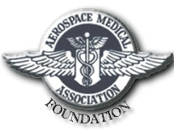

700 Gemini Street, Suite 110

Houston, TX 77058-2735
832-752-7651

I would like to support the AsMA Foundation with a tax deductible contribution.

Name:_____________________________ Gift Amount:_____________

Address: I would like to discuss creating a named endowed fund, restricted purpose fund or ____________________________ other method of donation.

___________________________

Phone Number:____________________

